Palash Bajpai

Low Level Design

Table of Contents
1. Introduction to Low-Level Design 2
2. SOLID Principles 3
1. Single Responsibility Principle (SRP) 5
2. Open/Closed Principle (OCP) 7
3. Liskov Substitution Principle (LSP) 9
4. Interface Segregation Principle (ISP) 11
5. Dependency Inversion Principle (DIP) 13
3. Design Patterns 15
4. Creational Design Patterns 17
1. Singleton Pattern 17
2. Factory Pattern 21
3. Abstract Factory Pattern 25
4. Builder Pattern 31
5. Prototype Pattern 36
5. Structural Design Patterns 41
1. Adapter Pattern 41
2. Facade Pattern 45
3. Decorator Pattern 49
4. Proxy Pattern 53
5. Composite Pattern 56
6. Flyweight Pattern 60
7. Bridge Pattern 63
6. Behavioural Design Patterns 67
1. Strategy Pattern 67
2. Command Pattern 71
3. Chain of Responsibility Pattern 76
4. Interpreter Pattern 81
5. Iterator Pattern 85
6. Mediator Pattern 89
7. Memento Pattern 94
8. Observer Pattern 99
9. State Pattern 104
10. Template Method Pattern 109
11. Visitor Pattern 113

1. Introduction to Low-Level Design

A system is a set of interconnected components working together to achieve a common goal, while system design is the process of defining and implementing the architecture, components, and interfaces of a system to fulfill specific requirements.
- High Level Design (HLD): describes system architecture details, database design, service and processes, relationship between different modules and features.
- Low Level Design (LLD): describes design of each component in detail, classes, interfaces, relationship between them.

Low Level Design
Low-Level Design (LLD) is the process of designing software at the component level. It provides detailed descriptions of modules, classes, methods, and interactions between system components. LLD focuses on implementation details, object-oriented design principles, and design patterns.

🔹 Key Characteristics of LLD
- Defines the structure of classes and objects.
- Includes UML diagrams such as Class Diagrams, Sequence Diagrams, and Component Diagrams.
- Follows Object-Oriented Programming (OOP) principles.
- Uses design patterns to solve common software design problems.

🔹 Importance of LLD
- Improved Code Maintainability: Well-structured code is easier to update and debug.
- Better Collaboration: LLD serves as a blueprint for developers, reducing misunderstandings.
- Optimized Performance: Proper design improves performance by reducing redundancy and increasing reusability.
- Enhanced Scalability: Well-designed software can be extended without major refactoring.
- Promotes Best Practices: Encourages the use of SOLID principles and design patterns.

2. SOLID Principles
SOLID is a set of five design principles that help software developers write maintainable, scalable, and robust code in object-oriented programming. These principles were introduced by Robert C. Martin (Uncle Bob) to improve software design and ensure that systems are easy to extend and modify.
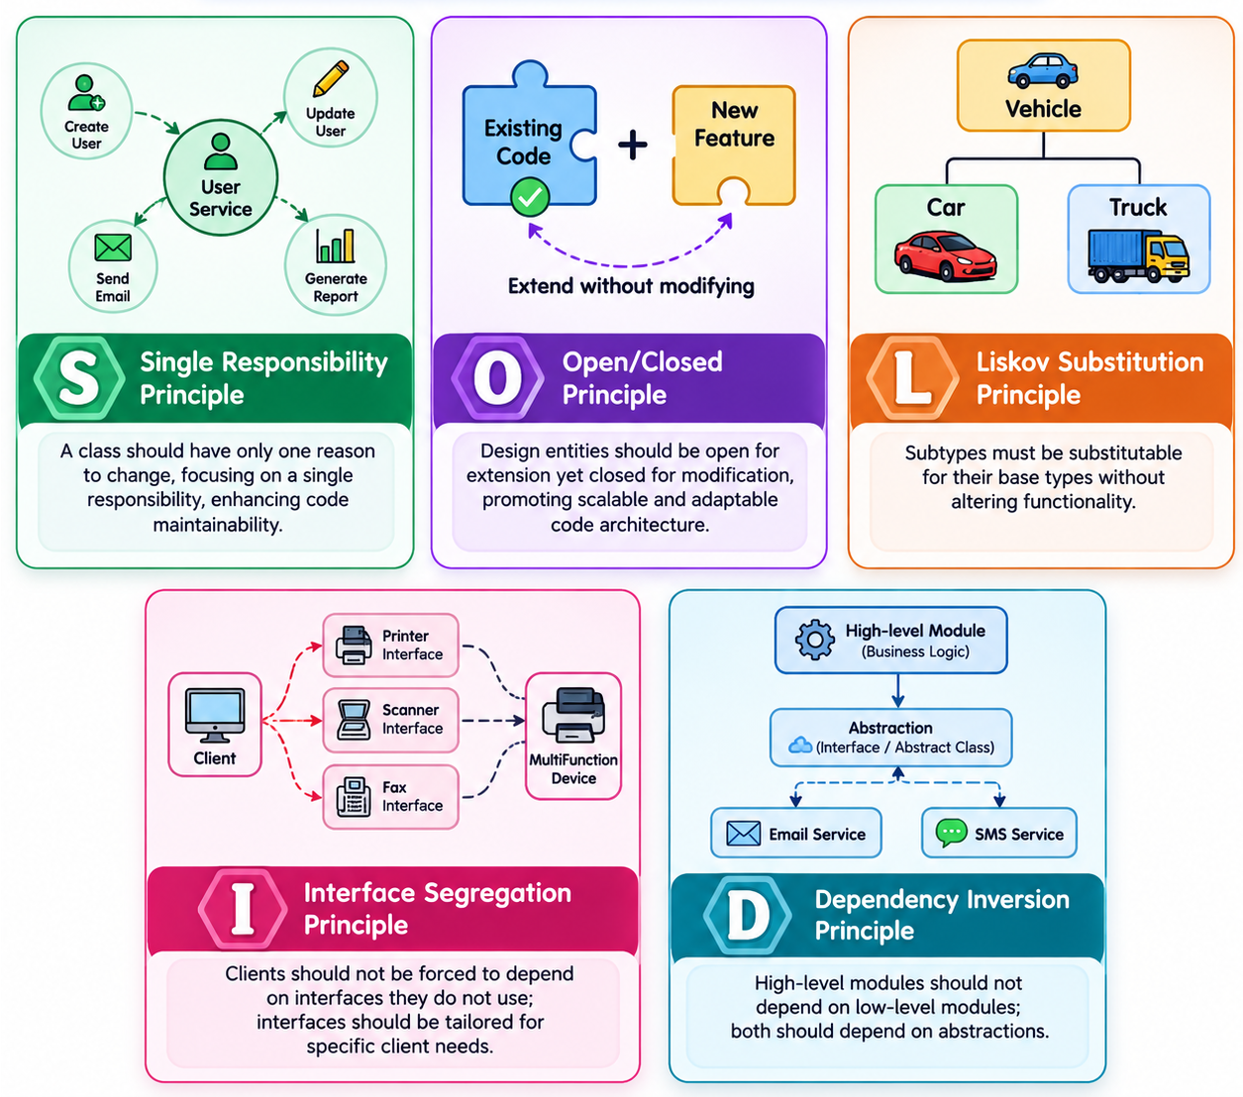

Principles | Description
S - Single Responsibility Principle (SRP) | A class should have only one reason to change.
O - Open/Closed Principle (OCP) | Code should be open for extension but closed for modification.
L - Liskov Substitution Principle (LSP) | Derived classes should be substitutable for their base classes.
I - Interface Segregation Principle (ISP) | Avoid forcing classes to implement unnecessary methods of an interface.
D - Dependency Inversion Principle (DIP) | High-level modules should not depend on low-level modules. Both should depend on abstractions

Advantages of using SOLID principle:-
- Better Maintainability: Each class has a single responsibility, making code easier to understand and modify.
- Scalability: New features can be added without modifying existing code.
- Loose Coupling: Dependency Inversion and Interface Segregation help reduce code dependencies.
- Easy Testing: Code becomes modular, allowing better unit testing and mocking.
- Better Collaboration: Developers can work on different parts of the system without causing conflicts.

Eg: - Consider building an e-commerce platform, if you follow SOLID principle
- Adding a new payment method (e.g., UPI) doesn't require modifying the entire payment system.
- Changing the notification system from SMS to Email won't break existing code.

Single Responsibility Principle (SRP)
The Single Responsibility Principle (SRP) states that a class should have only one reason to change. This means that a class should focus on only one functionality and should not mix multiple concerns. If a class handles multiple responsibilities, changes in one part of the system might affect unrelated parts, leading to fragile and tightly coupled code.
🔹 Key Takeaways of SRP
- A class should have one and only one responsibility.
- Changes in functionality should not impact unrelated features.
- Code should be modular, reusable, and easy to maintain.

Example: Book Management System:-
Imagine we are designing a Book Management System. A naive approach might be to create a single class that: Stores book details, Prints book details, Saves book details to a database
This violates SRP because the class is responsible for multiple things:
❌ Managing book data
❌ Handling printing logic
❌ Dealing with persistence (saving to the database)
//Bad Code (Multiple responsibilities in one class)
class Book {
private String title;
private String author;
public Book(String title, String author) {
this.title = title;
this.author = author;
}
// This method handles business logic (responsibility 1)
public void printBook() {
System.out.println("Title: " + title + ", Author: " + author);
}
// This method handles persistence (responsibility 2)
public void saveToDatabase() {
System.out.println("Saving book to database...");
}
}

// Good Code
// Book class - Handles only book data

class Book {
private String title;
private String author;
public Book(String title, String author) {
this.title = title;
this.author = author;
}
public String getTitle() {
return title;
}
public String getAuthor() {
return author;
}
}

// Separate class for printing
class BookPrinter {
public void printBook(Book book) {
System.out.println("Title: " + book.getTitle() + ", Author: " + book.getAuthor());
}
}

// Separate class for saving to database
class BookRepository {
public void saveToDatabase(Book book) {
System.out.println("Saving book to database: " + book.getTitle());
}
}

Why is this better?
- Each class has a single responsibility
- Changes in one part won’t affect unrelated functionalities
- Code is modular, reusable, and easy to test

Open/Closed Principle (OCP)
A class should be open for extension but closed for modification. This means that we should be able to extend a class’s behaviour without modifying its existing code. By doing this, we avoid introducing bugs into existing, tested code while still allowing enhancements.

🔹 Why OCP is important?
- Enhances maintainability – No need to modify existing classes when adding new features.
- Prevents unintended side effects – Since we don’t modify existing code, there's no risk of breaking functionality.
- Encourages scalability – New features can be added easily by extending the behaviour.

Example: E-commerce platform:-
Imagine you are building an e-commerce system that processes payments.
❌ Bad Approach: A PaymentProcessor class handles different payment methods:

//Bad design
class PaymentProcessor {
public void processPayment(String paymentType) {
if (paymentType.equals("CreditCard")) {
System.out.println("Processing credit card payment...");
} else if (paymentType.equals("PayPal")) {
System.out.println("Processing PayPal payment...");
} else {
System.out.println("Invalid payment method.");
}
}
}

- Every time a new payment method is added (e.g., Google Pay, Apple Pay), we need to modify processPayment().
- This violates OCP because the class is not closed for modification—we must edit the existing logic whenever a new type of payment is introduced.
- Use interfaces or abstract classes to allow extension.
🔹 Solution using OCP:
Instead of modifying the PaymentProcessor, we use polymorphism and abstraction to extend functionality without modifying the existing code.
// Step 1: Create an abstract Payment class
abstract class Payment {
abstract void process();
}

// Step 2: Implement different payment types
class CreditCardPayment extends Payment {
@Override
void process() {
System.out.println("Processing credit card payment...");
}
}
class PayPalPayment extends Payment {
@Override
void process() {
System.out.println("Processing PayPal payment...");
}
}
class GPay extends Payment {
@Override
void process() {
System.out.println("Processing PayPal payment...");
}
}

// Step 3: PaymentProcessor now works with any new payment type without modification
class PaymentProcessor {
public void processPayment(Payment payment) {
payment.process(); // Uses polymorphism to process payment
}
}

// Usage
public class Main {
public static void main(String[] args) {
PaymentProcessor processor = new PaymentProcessor();
Payment creditCard = new CreditCardPayment();
Payment paypal = new PayPalPayment();
processor.processPayment(creditCard);
processor.processPayment(paypal);
}
}

Liskov Substitution Principle (LSP)
"Subtypes must be substitutable for their base types without altering the correctness of the program." This means that if class B is a subclass of class A, then B should be usable in place of A without unexpected behaviour.

🔹 Why LSP is important?
- Ensures that inheritance is used correctly and meaningfully.
- Helps avoid breaking polymorphism by preventing unexpected behaviour.
- Promotes robust and maintainable code.

Example:
Imagine we are building a Bird Hierarchy for a wildlife simulation
❌ If we replace a Bird object with a Penguin, it violates expectations (penguins can’t fly!).
❌ The fly() method is not applicable to all subclasses of Bird.
❌ If client code calls fly(), it could crash unexpectedly(runtime exception)

//Bad Example
class Bird {
void fly() {
System.out.println("This bird can fly.");
}
}
class Sparrow extends Bird {
// Sparrow can fly - fine
}
class Penguin extends Bird {
// But penguins cannot fly!
@Override
void fly() {
throw new UnsupportedOperationException("Penguins cannot fly!");
}
}

🔹 Solution using LSP:
We should separate birds that can fly and those that cannot.
// Base interface for all birds
interface Bird {
void eat();
}
// Separate interface for birds that can fly
interface FlyingBird extends Bird {
void fly();
}

// Sparrow implements FlyingBird because it can fly
class Sparrow implements FlyingBird {
@Override
public void eat() {
System.out.println("Sparrow is eating.");
}
@Override
public void fly() {
System.out.println("Sparrow is flying.");
}
}

// Penguin implements only Bird, not FlyingBird
class Penguin implements Bird {
@Override
public void eat() {
System.out.println("Penguin is eating.");
}
}

//LSP ensures that subclasses can replace their parent classes without breaking functionality.
// Correctly designed client code
class BirdSanctuary {
public void letBirdFly(FlyingBird bird) {
bird.fly();
}
}

Interface Segregation Principle (ISP)
It states that “do not force any client to implement an interface which is irrelevant to them“. This means that instead of having large, general-purpose interfaces, we should create smaller, more specific interfaces that contain only the methods relevant to a particular client. This principle is the first principle that applies to Interfaces instead of classes in SOLID and it is similar to the single responsibility principle but specific to interfaces.

🔹 Difference between LSP and ISP
Principle | Focus | Problem It Solves | Solution
Liskov Substitution Principle (LSP) | Ensures that subclasses can replace parent classes without breaking behaviour. | Inheritance misuse where a subclass changes the behaviour of the base class. | Use correct abstraction to ensure child classes fully comply with the parent class’s expected behaviour.
Interface Segregation Principle (ISP) | Ensures that clients do not depend on methods they do not use. | Large, “fat” interfaces that force classes to implement unnecessary methods. | Split interfaces into smaller, more specific ones so that classes implement only what they need.
👉 LSP is about subclass relationships, while ISP is about breaking down interfaces properly.

Example: ❌ Bad Example

//Bad example

interface Printer {
void print();
void scan();
void fax();
}

- A basic printer may support only print().
- A multifunction printer (MFP) may support print(), scan(), and fax().
- Forcing all printers to implement scan() and fax() even if they don’t support these features violates ISP.
🔹 Solution using ISP:
Split the interface
// Interface for basic printing functionality
interface Printer {
void print();
}

// Interface for scanning functionality
interface Scanner {
void scan();
}

// Interface for fax functionality
interface Fax {
void fax();
}

// Basic printer only implements Printer
class BasicPrinter implements Printer {
@Override
public void print() {
System.out.println("Printing document...");
}
}

// Multifunction printer implements all three interfaces
class MultiFunctionPrinter implements Printer, Scanner, Fax {
@Override
public void print() {
System.out.println("Printing document...");
}
@Override
public void scan() {
System.out.println("Scanning document...");
}
@Override
public void fax() {
System.out.println("Sending fax...");
}
}

Dependency Inversion Principle (DIP)
"High-level modules should not depend on low-level modules. Both should depend on abstractions (interfaces or abstract classes)."

- In simpler terms, the DIP suggests that classes should rely on abstractions (e.g., interfaces or abstract classes) rather than concrete implementations.
- This allows for more flexible and decoupled code, making it easier to change implementations without affecting other parts of codebase.
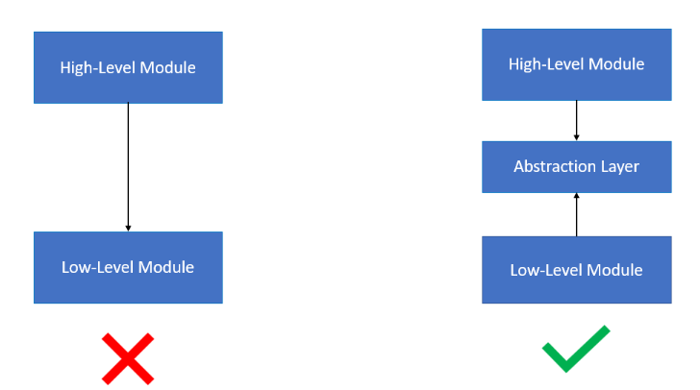

🔹 Why DIP is important?
- Without DIP, changes in low-level modules break high-level modules.
- Hard dependencies make it difficult to modify or extend functionality.
- Following DIP makes code more maintainable, modular, and adaptable to future changes.

Bad Example: ❌Payment Processing Example
- OrderService is tightly coupled to PayPalPayment.
- If we want to add StripePayment or GooglePayPayment, we must modify OrderService, breaking the Open/Closed Principle (OCP).
- Testing is difficult because OrderService cannot work with mock payment processors.
class PayPalPayment {
void processPayment(double amount) {
System.out.println("Processing payment of $" + amount + " via PayPal.");
}
}

class OrderService {
private PayPalPayment paymentProcessor = new PayPalPayment(); // Direct dependency
void checkout(double amount) {
paymentProcessor.processPayment(amount);
}
}

🔹 Solution using DIP:
// Define an abstraction (interface)
interface PaymentProcessor {
void processPayment(double amount);
}

// Implement PayPal payment processing
class PayPalPayment implements PaymentProcessor {
@Override
public void processPayment(double amount) {
System.out.println("Processing payment of $" + amount + " via PayPal.");
}
}

// Implement Stripe payment processing
class StripePayment implements PaymentProcessor {
@Override
public void processPayment(double amount) {
System.out.println("Processing payment of $" + amount + " via Stripe.");
}
}

// High-level module depends on abstraction
class OrderService {
private final PaymentProcessor paymentProcessor;
// Inject dependency via constructor
public OrderService(PaymentProcessor paymentProcessor) {
this.paymentProcessor = paymentProcessor;
}
void checkout(double amount) {
paymentProcessor.processPayment(amount);
}
}

Design Patterns
Design patterns are proven solutions to common software design problems. They offer best practices to structure and optimize software development, helping developers create scalable, maintainable, and reusable code. They are not strict rules but guidelines that facilitate effective software design.

🔹 Why use design pattern?
- Improve Code Maintainability - Design patterns encourage a structured and organized approach, making it easier to maintain and modify code over time.
- Increase Code Reusability - Patterns allow components to be reused across different projects, reducing redundancy.
- Enhance Scalability and Flexibility - Well-structured code ensures that applications can scale efficiently without major changes.
- Reduce Development Time - Patterns provide pre-defined solutions, allowing developers to focus on business logic rather than reinventing the wheel.

Types of Design Pattern:

- Creational Design Patterns
Creational patterns deal with the efficient creation of objects while hiding the instantiation logic.

Pattern | Purpose | Example
Singleton | Ensures only one instance of a class exists. | Logger, Database Connection
Factory | Delegates object creation to subclasses. | ShapeFactory returning Circle or Rectangle
Abstract Factory | Creates related objects without specifying concrete classes. | GUIFactory producing WindowsButton or MacButton
Builder | Step-by-step creation of complex objects. | MealBuilder for creating VegMeal or NonVegMeal
Prototype | Creates new objects by cloning an existing object. | Document.clone() method

- Structural Design Patterns
Structural patterns help in organizing classes and objects to create flexible and scalable architectures.
Pattern | Purpose | Example
Adapter | Converts one interface into another. | USB-to-Ethernet Adapter
Facade | Provides a simplified interface to a complex system. | JDBC Connection
Decorator | Adds functionality dynamically without modifying the original class. | BufferedReader wrapping FileReader
Proxy | Controls access to another object. | Virtual Proxy, Security Proxy
Composite | Treats individual and composite objects uniformly. | Folder containing Files and SubFolders
Flyweight | Shares objects to reduce memory usage. | Character Objects in a Text Editor
Bridge | Decouples abstraction from implementation. | RemoteControl → TV (SonyRemote, LGRemote)

- Behavioural Design Patterns
Behavioural patterns define communication and responsibilities among objects.
Pattern | Purpose | Example
Strategy | Defines a family of algorithms and selects one at runtime. | Sorting Algorithms (MergeSort, QuickSort)
Command | Encapsulates a request as an object. | Undo/Redo System in Text Editors
Chain of Responsibility | Passes requests along a chain of handlers. | Logging System (Error → Warning → Info)
Interpreter | Defines a grammar for language interpretation. | SQL Query Parser
Iterator | Sequentially accesses elements of a collection. | Java Iterator, Python Itertools
Mediator | Defines a central object for object communication. | Chat Room, Traffic Controller
Memento | Saves object states for rollback. | Undo feature in MS Word
Observer | Notifies dependent objects of state changes. | Event Listeners in UI
State | Allows object to change behaviour based on its state. | Vending Machine States
Template Method | Defines the skeleton of an algorithm and allows subclasses to fill in details. | Data Processing Pipelines
Visitor | Allows adding operations to objects without modifying their structure. | AST (Abstract Syntax Tree) Traversal

Creational Design Patterns

1. Singleton Pattern
The Singleton pattern restricts the instantiation of a class to a single object and provides a way to access it globally. It is used when only one instance of a class is needed to coordinate actions across a system.

🔹 Key Points
Aspect | Detail
Problem Solved | Prevents multiple instances of class being created
Type | Creational Pattern
Principle | Restricts object creation to single instance
Access | Provides a global access point
Best Used | Logging, Configuration, Database Connections, Caching, Thread Pool

🔹 Implementation of Singleton Pattern:
class Singleton {
private static Singleton instance;
//make constructor private, so no other class can create object directly
private Singleton() { }
//The getInstance() method is used to access the single instance
public static Singleton getInstance() {
if (instance == null) {
instance = new Singleton();
}
return instance;
}
}
- Lazy initialization in the Singleton pattern ensures that the instance is created only when it is needed for the first time, rather than at the time of class loading
- In a multithreaded environment, the Singleton pattern often uses synchronized methods to ensure that only one instance is created
- To ensure that a Singleton object cannot be cloned, you should override the clone() method and throw CloneNotSupportedException to prevent the creation of multiple instances.
🔹 Real World Example: Design a logging service
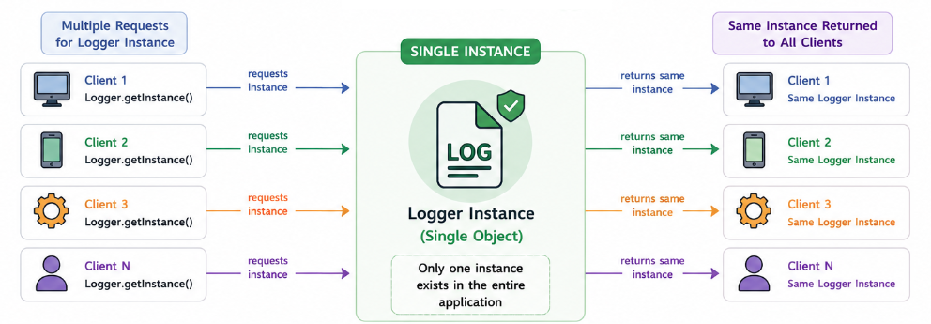

Step 1: Singleton Class
import java.text.SimpleDateFormat;
import java.util.Date;
public class Logger {
private static Logger instance;
private Logger() {} //Prevents direct object creation using new keyword
public static synchronized Logger getInstance() { //object creation only via this method
if (instance == null) {
instance = new Logger();
}
return instance;
}
public void info(String message) {
log("INFO", message);
}
public void warn(String message) {
log("WARN", message);
}
public void error(String message) {
log("ERROR", message);
}
private void log(String level, String message) {
String timestamp = new SimpleDateFormat("yyyy-MM-dd HH:mm:ss").format(new Date());
System.out.println(String.format("%s [%s]: %s", timestamp, level, message));
}
}

Step 2: Client Code

package Singleton;
import java.util.Scanner;
public class Exercise {
public void run() {
Logger logger = Logger.getInstance();
Scanner sc = new Scanner(System.in);
//Log the info message using the appropriate logging method.
System.out.print("Enter an info message: ");
String infoMessage = sc.nextLine();
logger.info(infoMessage);
// Log the warn message using the appropriate logging method.
System.out.print("Enter a warning message: ");
String warnMessage = sc.nextLine();
logger.warn(warnMessage);
//Log the error message using the appropriate logging method.
System.out.print("Enter an error message: ");
String errorMessage = sc.nextLine();
logger.error(errorMessage);
sc.close();
}
}

🔹 Real-World Examples:
- Spring Beans (Singleton Scope) – By default, Spring creates one shared bean instance per IoC container, which is reused across the application.
- Logger – A single logger instance is shared to write application logs consistently.
- Configuration Manager – Loads configuration files once and provides global access to settings.
- Database Connection Pool – Manages a shared pool of database connections for all services.
- Cache Manager – Maintains a single cache instance for efficient data retrieval.
- Thread Pool Manager – Provides a centralized pool of reusable threads.
- Printer Spooler – Coordinates print jobs through a single print queue.
- Runtime Class (Runtime.getRuntime()) – Java provides a single Runtime instance representing the current JVM.

🔹 Adheres to SOLID Principles:
- Open/Closed Principle (OCP): Singleton behaviour can be extended without modifying client code.
- Dependency Inversion Principle (DIP): Clients should ideally depend on an abstraction rather than directly on the Singleton implementation (often achieved through dependency injection).
Note: Singleton can conflict with Single Responsibility Principle (SRP) because it manages both its primary responsibility and its own lifecycle (instance creation).

🔹 When to use:
Use the Singleton Pattern when:
- Exactly one instance of a class should exist.
- A shared resource needs centralized management.
- Multiple components need access to the same object.
- You are implementing loggers, configuration managers, cache managers, connection pools, or thread pools.
- Creating multiple instances would lead to inconsistency, resource wastage, or synchronization issues.

🔹 Advantages:
- Ensures only one object exists.
- Saves memory by avoiding duplicate objects.
- Provides global access to shared resources.
- Useful for centralized management.
- Supports lazy initialization.

2. Factory Pattern

The Factory Pattern is a creational design pattern that provides a way to create objects without specifying the exact class that should be instantiated.
👉 The Factory Pattern helps centralize the creation logic and delegates the responsibility of creating objects to factory classes, which decide the specific class to instantiate.
👉 Key Idea: Instead of using new to create objects in the client code (service call), we delegate object creation to a dedicated method (factory class).

🔹 Key Points
Aspect | Detail
Problem Solved | Eliminates direct object creation using new in client code
Type | Creational Pattern
Principle | Encapsulates object creation logic in a factory
Flexibility | New object types can be added with minimal client changes
Best Used | When the exact type of object is determined at runtime

🔹 Real-World Example: Notification Service
❌ Without Factory Pattern (Direct Instantiation)
String type = "EMAIL";
Notification notification;
if(type.equals("EMAIL")){
notification = new EmailNotification();
}else if(type.equals("SMS")){
notification = new SMSNotification();
}else{
notification = new PushNotification();
}
notification.send();

- Large if-else or switch statements
- Tight coupling with concrete classes
- Difficult to introduce new notification types
- Violates Open/Closed Principle.
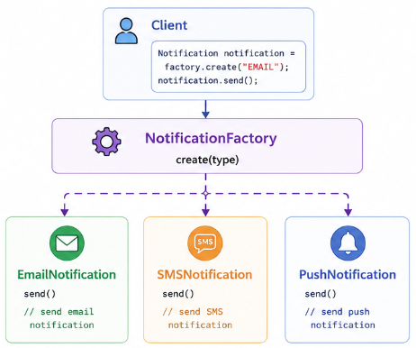
🔹 Implementation with Factory Pattern

Step 1: Product Interface
public interface Notification {
void send(); //send the notification (can be big logical code)
}

Step 2: Concrete Products
public class EmailNotification implements Notification {
@Override
public void send(){
//May contain large code
System.out.println("Sending Email Notification...");
}
}

public class SMSNotification implements Notification{
@Override
public void send(){
System.out.println("Sending SMS notification.....");
}
}

public class PushNotification implements Notification{
@Override
public void send(){
System.out.println("Sending push notification.....");
}
}
Step 3: Factory Class
public class NotificationFactory {
//Make it static : this creates required Notification classes
public static Notification getNotification(String type){
switch(type.toLowerCase()){
case "email":
return new EmailNotification();
case "sms":
return new SMSNotification();
case "push":
return new PushNotification();
default:
throw new IllegalArgumentException("Invalid Notification Type");
}
}
}

Step 4: Client Code
import org.example.NotificationSystem.Notification;
import org.example.NotificationSystem.NotificationFactory;
public class Main {
public static void main(String[] args) {
//Client ask factory for Email Notification
Notification email = NotificationFactory.getNotification("Email");
email.send();
Notification sms = NotificationFactory.getNotification("sms");
sms.send();
}
}

🔹 Real-World Examples
- JDBC DriverManager – Returns the appropriate database connection based on the JDBC URL and driver.
- Spring BeanFactory – Creates and manages bean instances based on configuration.
- Logger Factory (SLF4J) – Returns the appropriate logger implementation without exposing concrete logger classes.
- Payment Gateway – Creates UPI, Credit Card, or PayPal payment processors based on user choice.
- Database Connection Factory – Creates the correct database connection object based on configuration.
- Document Editors – Creates PDF, Word, or Excel document objects based on the requested format.
🔹 Adheres to SOLID Principle
- Single Responsibility Principle (SRP): The factory is responsible only for object creation, while product classes focus on their behaviour.
- Open/Closed Principle (OCP): New product types can be added with minimal changes to the client (though the simple factory itself usually requires modification).
- Dependency Inversion Principle (DIP): The client depends on the Notification abstraction instead of concrete implementations.

✅ Use the Factory Pattern when:
- You need multiple implementations of an interface and want to decouple object creation.
- Object creation is complex and involves configuration settings or dependencies.
- You want to centralize object creation logic instead of scattering new keywords across your codebase.
- You need flexibility in choosing an implementation at runtime.

🚫 Avoid Factory Pattern if:
- You have a small number of classes and no need for dynamic object creation.
- Object creation is simple and does not require additional logic.

3. Abstract Factory Pattern

The Abstract Factory Pattern provides an interface for creating families of related or dependent objects without specifying their concrete classes.
👉Instead of creating objects directly, the client interacts with an abstract factory that provides methods to create different objects.
👉This ensures that related objects are created consistently, reducing tight coupling.

🔹 Key Points
Aspect | Detail
Problem Solved | Creates families of related objects without exposing concrete classes
Type | Creational Pattern
Principle | Encapsulates creation of related objects into factories
Flexibility | Easily switch between entire product families
Best Used | Cross platform UI, Themes, Database Drivers, Game Engines

🔹 Real-World Example: Cross Platform UI
❌Without Abstract Factory Pattern (Direct Instantiation):
Imagine we are building a cross-platform UI library that needs to create buttons and checkboxes differently for Windows and MacOS.

class Application {
void createUI(String osType) {
if (osType.equals("Windows")) {
WindowsButton button = new WindowsButton();
WindowsCheckbox checkbox = new WindowsCheckbox();
button.render();
checkbox.render();
} else if (osType.equals("MacOS")) {
MacOSButton button = new MacOSButton();
MacOSCheckbox checkbox = new MacOSCheckbox();
button.render();
checkbox.render();
}
}
}

Problem with above code:
- Code duplication due to if else logic
- Difficult to extend, as if new OS is added, client code needs to be modified
- No code is stopping to create MacOSCheckbox with WindowsButton, which are incompatible with each other.
- Application class directly depends on concrete classes like WindowsButton.

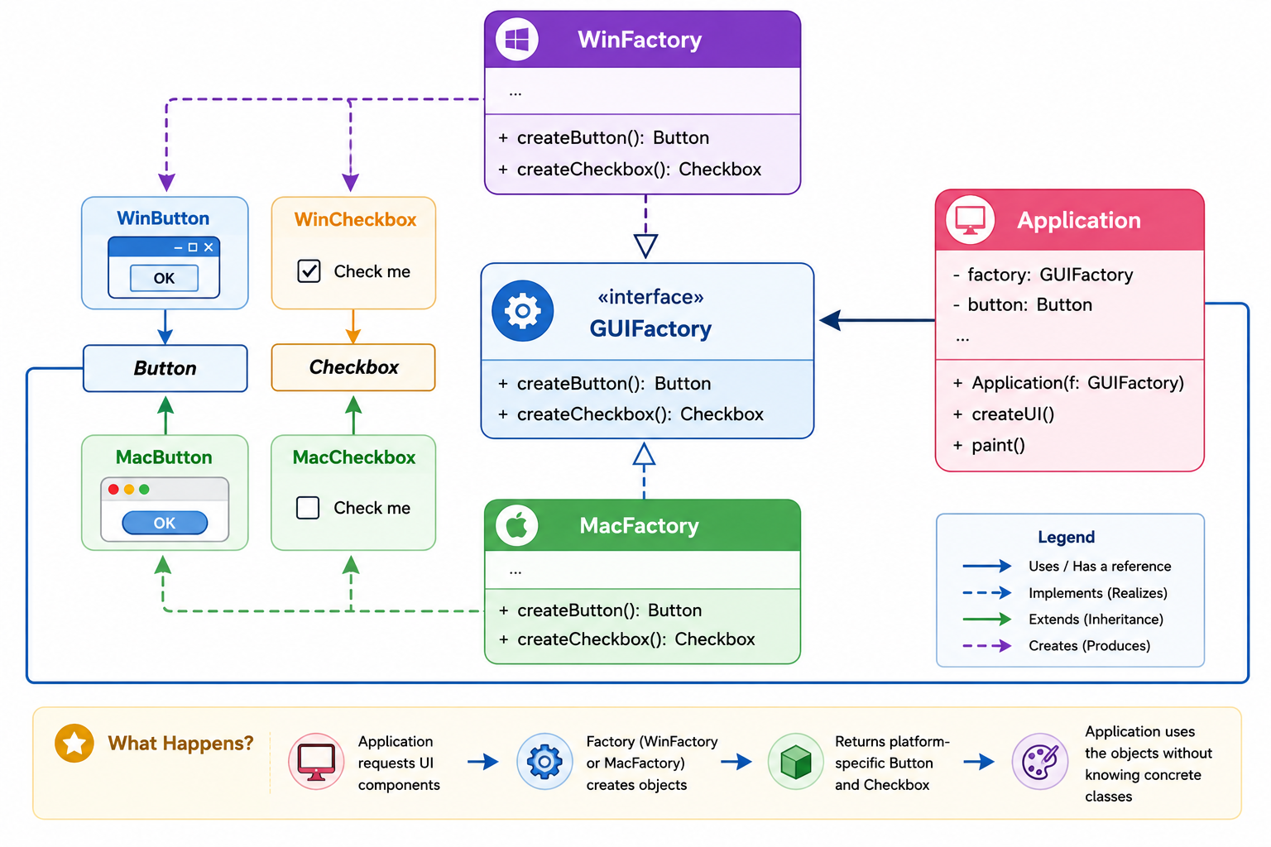🔹 Implementation with Abstract Factory Pattern

- Abstract Factory: Interface for creating abstract products.
- Concrete Factory: Implements the abstract factory and creates concrete products.
Using the Abstract Factory Pattern, you create interfaces for each product (e.g., Button, ScrollBar, and Window) and provide a family of concrete implementations for each theme (e.g., WindowsButton, MacOSButton, etc.).
Step 1: Abstract Interfaces (Button, Checkbox)

public interface Button {
void render();
}

public interface Checkbox {
void render();
}

Step 2: Concrete Implementations (Button, Checkbox)
public class WindowsButton implements Button{
@Override
public void render(){
System.out.println("Rendering Windows Button");
}
}

public class MacButton implements Button {
@Override
public void render(){
System.out.println("Rendering Mac Button");
}
}

public class WindowsCheckbox implements Checkbox{
@Override
public void render(){
System.out.println("Rendering Windows Checkbox");
}
}

public class MacCheckbox implements Checkbox{
@Override
public void render(){
System.out.println("Rendering Mac Checkbox");
}
}

Step 3: Abstract Factory Interface
public interface GUIFactory {
Button createButton();
Checkbox createCheckbox();
}
Step 4: Concrete Implementation ( Windows, Mac)

public class WindowsFactory implements GUIFactory{
@Override
public Button createButton(){
return new WindowsButton();
};
@Override
public Checkbox createCheckbox(){
return new WindowsCheckbox();
}
}

public class MacFactory implements GUIFactory{
@Override
public Button createButton(){
return new MacButton();
}
@Override
public Checkbox createCheckbox(){
return new MacCheckbox();
}
}

Step 5: Application Code

//Uses GUI factory
//Just combines rendering of objects together
public class Application {
private Button button;
private Checkbox checkbox;
public Application(GUIFactory factory){
this.button = factory.createButton();
this.checkbox = factory.createCheckbox();
}
public void renderUI(){
button.render();
checkbox.render();
}
}
Step 6: Client Code

public class Main {
public static void main(String[] args) {
GUIFactory factory;
String osType = "Windows";
if(osType.equals("Windows")){
factory = new WindowsFactory();
}else{
factory = new MacFactory();
}
Application app = new Application(factory);
app.renderUI();
}
}

🔹 Real-World Examples
- Java Swing Look & Feel – Creates platform-specific UI components for Windows, macOS, or other themes.
- Spring BeanFactory / ApplicationContext – Produces related beans based on configuration profiles.
- Database Driver Libraries – Create compatible connections, statements, and result sets for different databases.
- Cross-Platform UI Toolkits – Generate Windows, macOS, or Linux widgets.
- Furniture Manufacturing – Create matching furniture collections (Modern, Victorian, Art Deco).
- Vehicle Manufacturing – Produce economy or luxury vehicle families.
- Game Development – Generate desert, forest, or snow-themed game objects.
- Cloud Providers – Create AWS, Azure, or GCP service implementations.

🔹 Adheres to SOLID Principles
- Single Responsibility Principle (SRP): Each factory is responsible for creating one family of related products.
- Open/Closed Principle (OCP): New product families can be introduced by adding new factories without modifying client code.
- Dependency Inversion Principle (DIP): The client depends on abstract factories and abstract products rather than concrete implementations.
✅ Use the Abstract Factory Pattern when:
- You need to create related objects that must be used together (e.g., UI components).
- You want to ensure compatibility between created objects.
- You need flexibility in choosing between different implementations at runtime.
- You want to enforce consistency by ensuring that objects from the same family are used together.

🚫 Avoid Abstract Factory Pattern if:
- You don’t need to create families of related objects.
- Object creation logic is simple and doesn’t require multiple variations.

Difference between Factory and Abstract Factory:
Feature | Factory Pattern | Abstract Factory Pattern
Purpose | Creates objects of a single type | Creates families of related objects
Flexibility | Less flexible; one factory per type | More flexible; centralizes multiple factories
Scalability | Limited to a single product type | Supports multiple related products
Example | Payment processing factory | UI Component factory (Windows/Mac)

4. Builder Pattern

The Builder Pattern is a creational design pattern that helps in constructing complex objects step by step. It allows you to separate the construction process from the actual object representation (following SRP), making object creation more flexible and readable.
👉 Instead of creating objects with long constructor parameters (telescoping constructors), the Builder pattern provides a fluent API to build objects conveniently.

🔹 Key Points
Aspect | Detail
Problem Solved | Simplifies the creation of complex objects with many optional parameters
Type | Creational Pattern
Principle | Builds an object step-by-step instead of using large constructors
Flexibility | Allows different representations of the same object
Best Used | Objects with many optional fields or complex construction logic.

🔹 Real-World Example: Building a Burger

❌ Without Builder Pattern (Building a burger)

class Burger {
private String size; //mandatory
private String patty; //mandatory
private String sauce; //optional
private boolean cheese; //optional
private boolean tomato; //optional
// Constructor with many parameters (Telescoping Constructor Problem)
public Burger(String size,String patty, String sauce, boolean cheese,boolean tomato) {
this.size = size;
this.patty = patty;
this.sauce = sauce;
this.cheese = cheese;
this.tomato = tomato;
}
@Override
public String toString() {
return "Burger{" + "size='" + size + ", patty='" + patty + ", sauce='" + sauce + ", cheese=" + cheese + ", tomato=" + tomato + '}';
}
}
public class Main {
public static void main(String[] args) {
// Difficult to understand what parameters mean
Burger burger = new Burger("Large", "Aloo", "Mint Mayo", true, false);
System.out.println(burger);
}
}

Problem with above code:
- Difficult to read – What does true, false, true, false mean?
- Unnecessary arguments – What if the user wants a default burger?
- Hard to extend – Adding new ingredients means modifying the constructor.
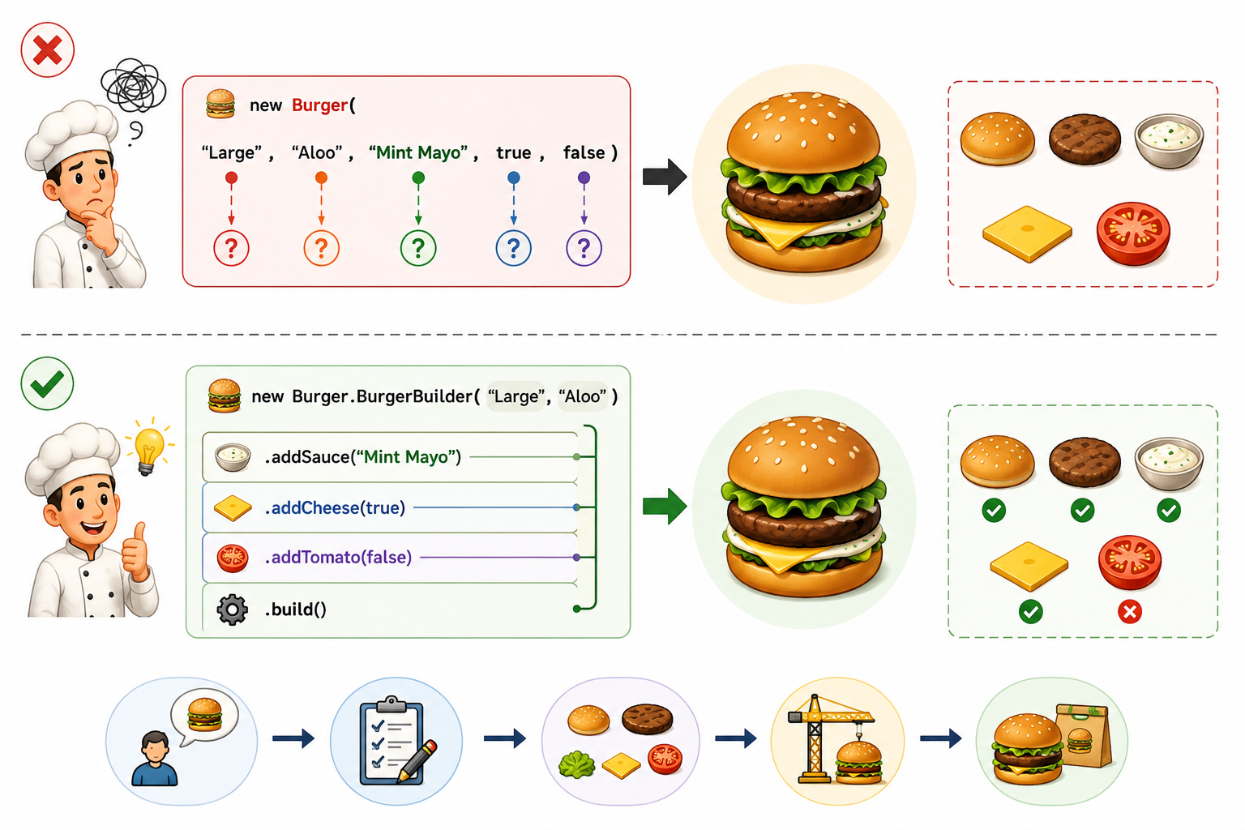🔹 Implementation with Builder Pattern

class Burger { //Product Class
private String size; //mandatory
private String patty; //mandatory
private String sauce; //optional
private boolean cheese; //optional
private boolean tomato; //optional
private Burger(BurgerBuilder builder) { // Private constructor to force use of Builder
this.size = builder.size;
this.patty = builder.patty;
this.sauce = builder.sauce;
this.cheese = builder.cheese;
this.tomato = builder.tomato;
}
@Override
public String toString() {
return "Burger{" + "size='" + size + ", patty='" + patty + ", sauce='" + sauce + ", cheese=" + cheese + ", tomato=" + tomato + '}';
}
public static class BurgerBuilder { // Static Inner Builder Class
private String size; //mandatory
private String patty; //mandatory
private String sauce = "Tomato Sauce"; //giving default value
private boolean cheese; //optional, defaults to false
private boolean tomato; //optional, , defaults to false
public BurgerBuilder(String size, String patty) { // Mandatory parameter
this.size = size;
this.patty = patty;
}
public BurgerBuilder addSauce(String sauce) {
this.sauce = sauce;
return this;
}
public BurgerBuilder addCheese(boolean cheese) {
this.cheese = cheese;
return this;
}
public BurgerBuilder addTomato(boolean tomato) {
this.tomato = tomato;
return this;
}
public Burger build() { // Build method to create final object
return new Burger(this);
}
}
}
Step 2: Client Code

//Client code to handle burger creation
public class Main {
public static void main(String[] args) {
Burger burger = new Burger.BurgerBuilder("Large","Aloo")
.addSauce("Mint Mayo")
.addCheese(true) //chaining method call
.addTomato(true)
.build();
System.out.println(burger);
Burger burger2 = new Burger.BurgerBuilder("Small","Chicken")
.addTomato(true)
.build();
}
}

Explanation: Inside Burger class, we created a nested static class BurgerBuilder, which create the burger. Burger has different set methods, which return BurgerBuilder only, so that while calling, these methods can be chained.
BurgerBuilder also have build method, which at the end calls the private constructor of Burger and returns Burger object.

🔹 Key Features of Builder Pattern:
✔ Step-by-step object construction
✔ Readable and maintainable code
✔ Immutability – Objects can be made immutable after creation (by setting values to final)
✔ Avoids complex telescoping constructor
✔ No need to remember order of values to be set for constructor.

🔹 Java Example:
HttpRequest request = new HttpRequest.Builder()
.setUrl("https://api.example.com")
.setMethod("POST")
.setHeader("Content-Type", "application/json")
.setBody("{ \"name\": \"John\" }")
.build();

🔹 Real-World Examples
- Lombok @Builder – Automatically generates builder classes for Java objects.
- Java StringBuilder – Builds complex strings efficiently by appending parts step-by-step.
- Spring Framework UriComponentsBuilder – Constructs URLs using a fluent API.
- HTTP Request Builders – Used by libraries like OkHttp and Apache HttpClient to create requests.
- Pizza Ordering Systems – Build customized pizzas with different toppings.
- Computer Configuration – Assemble systems with optional hardware components.
- House Construction – Build houses with optional features like garage, pool, or garden.
- Employee Creation – Construct employee objects with mandatory and optional fields.

🔹 Adheres to SOLID Principles
- Single Responsibility Principle (SRP): The Builder handles object construction, while the Product focuses on business logic.
- Open/Closed Principle (OCP): New optional fields can often be added by extending the builder without changing client code.
- Dependency Inversion Principle (DIP): Clients depend on the builder abstraction rather than complex constructors.

5. Prototype Pattern

The Prototype Pattern is a creational design pattern that allows cloning an object instead of creating a new instance from scratch. It provides a mechanism to create objects by copying an existing object (prototype).

🔹 When to use Prototype Pattern
Scenario | Why Prototype Helps
Objects are expensive to create | Cloning avoids costly instantiations
Need multiple instances of an object with  minor changes | Clone the object and modify specific fields
Reduce dependency on constructors | Simplifies object creation logic
Need to maintain object history (versioning) | Cloning preserves previous states

🔹 Shallow Vs Deep copy
In most cases, eg for case where we need to store the previous state of anything like a game. So in such cases we need to store deep copy, so that current state don’t change values in previous state. By default, Java’s clone() method creates a shallow copy, meaning nested objects are not cloned.
- Shallow Copy: Creates a new object but does not clone the objects that the original object refers to.
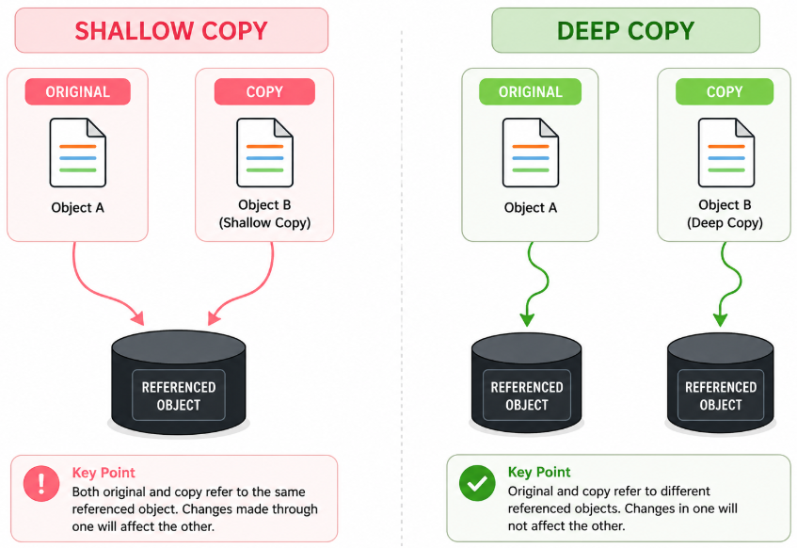
- Deep Copy: Clones the original object and all the objects it refers to (nested objects)

❌ Without Prototype Pattern (Storing current state of chess game, for undo redo functionality)
Problem with below code:
- To make deep copy for all pieces, we have to call constructor many times.
- Clone logic is present in client code. Violation of SRP
- Any changes in constructor of piece, will cause changes in client code. Violates OCP
public class Piece {
private String name;
private String position;
public Piece(String name, String position){
this.name = name;
this.position = position;
}
public String getName() {
return name;
}
public String getPosition() {
return position;
}
@Override
public String toString() {
return "Piece{" + "name='" + name + '\'' + ", position='" + position + '\'' + '}';
}
}

public class ChessBoard {
private List<Piece> pieces = new ArrayList<>();
public void addPiece(Piece piece){
pieces.add(piece);
}
public List<Piece> getPieces(){
return pieces;
}
public void showBoardState(){
for(Piece piece:pieces){
System.out.println(piece);
}
}
}

public class GameWithoutPrototype {
public static void main(String[] args) {
ChessBoard chessBoard = new ChessBoard();
chessBoard.addPiece(new Piece("Rook","a3"));
chessBoard.addPiece(new Piece("Bishop","c5"));
chessBoard.showBoardState();
//save the state
ChessBoard copiedBoard = new ChessBoard();
for(Piece piece: chessBoard.getPieces()){//deep copy
copiedBoard.addPiece(new Piece(piece.getName(), piece.getPosition()));
}
System.out.println("Copied Board");
copiedBoard.showBoardState();
}
}

🔹 Implementation with Prototype Pattern
public class Piece {
private String name;
private String position;
public Piece(String name, String position){
this.name = name; //Can have expensive validations
this.position = position; //validations
//multiple other checks may run
}
//light-weight constructor, used for cloning(no validations and checks)
public Piece(Piece piece){
this.name = piece.name;
this.position = piece.position;
}
public String getName() {
return name;
}
public String getPosition() {
return position;
}
@Override
public String toString() {
return "Piece{"+"name='"+ name + '\''+ ",position='"+position+'\''+'}';
}
@Override //creating deep copy of piece using lightweight constructor
public Piece clone() {
return new Piece(this);
}
}

public class ChessBoard{
private List<Piece> pieces = new ArrayList<>();
public void addPiece(Piece piece){
pieces.add(piece);
}
public List<Piece> getPieces(){
return pieces;
}
public void showBoardState(){
for(Piece piece:pieces){
System.out.println(piece);
}
}
@Override
public ChessBoard clone() {
ChessBoard clonedBoard = new ChessBoard();
for(Piece piece:pieces){
clonedBoard.addPiece(piece.clone());
}
return clonedBoard;
}
}

public class GameWithPrototype {
public static void main(String[] args) {
ChessBoard chessBoard = new ChessBoard();
chessBoard.addPiece(new Piece("Rook","a3"));
chessBoard.addPiece(new Piece("Bishop","c5"));
chessBoard.showBoardState();
//Save this state
ChessBoard copiedBoard = chessBoard.clone();
System.out.println("Copied Board");
copiedBoard.showBoardState();
}
}

✅ Key takeaways:
- Prototype Pattern is useful when object creation is expensive.
- Reduces constructor dependency and improves performance.
- Use deep cloning to avoid shared references in complex objects.
- Works well when multiple copies of an object with slight variations are needed.

🔹 Real-World Examples
- Chess Games – Clone the board after each move to implement Undo/Redo functionality.
- Microsoft Word / Google Docs – Maintain document snapshots for undo and version history.
- Java Object.clone() – Built-in cloning mechanism (though often replaced with copy constructors or custom cloning).
- Game Save Systems – Save player progress by cloning the current game state.
- Graphic Design Tools – Duplicate shapes, images, or layers.
- Workflow Engines – Clone process definitions before applying modifications.
- Object Caching – Return cloned cached objects instead of recreating them.
- CAD Software – Duplicate engineering models while preserving their current state.

🔹 Adheres to SOLID Principles
- Single Responsibility Principle (SRP): The object manages its own cloning logic, while clients simply request copies.
- Open/Closed Principle (OCP): New prototype types can be introduced without changing client code.
- Dependency Inversion Principle (DIP): Clients depend on the Prototype abstraction rather than concrete classes.

Structural Design Patterns

1. Adapter Pattern
The Adapter Pattern is a structural design pattern that allows incompatible interfaces to work together by acting as a bridge between them. It enables an existing class with a different interface to be used as if it were a different interface, without modifying its source code.
The Adapter pattern allows for the integration of new interfaces with existing classes, adhering to the Open/Closed Principle by enabling extension of functionality without altering existing code.

🔹 Working Strategy
- Convert the interface of a class into another interface that clients expect.
- Bridge the gap between legacy code and new code.
- Facilitate the reuse of existing classes without modifying their implementation.

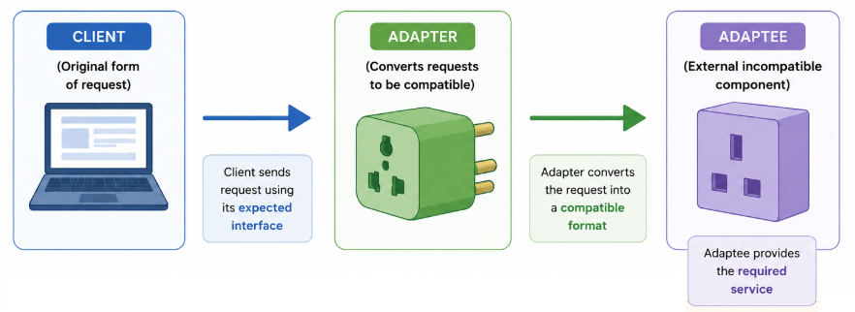

🔹 Implementation with Adapter Pattern
Scenario: We have an existing music player that plays only MP3 files. Now, we need to add support for MP4 and VLC files without modifying the existing MediaPlayer class.
Step 1: Define the Target Interface and Existing Player
// Target interface that client expects
interface MediaPlayer {
void play(String audioType, String fileName);
}
// Existing class that can play only MP3 files
class MP3Player implements MediaPlayer {
@Override
public void play(String audioType, String fileName) {
if (audioType.equalsIgnoreCase("mp3")) {
System.out.println("Playing MP3 file: " + fileName);
} else {
System.out.println("Invalid media type: " + audioType);
}
}
}

Step 2: Create the Adaptee (New classes with different interfaces)
// Adaptee interface (New functionality that needs to be adapted)
interface AdvancedMediaPlayer {
void playMP4(String fileName);
void playVLC(String fileName);
}
// Concrete classes implementing the new functionality
class MP4Player implements AdvancedMediaPlayer {
@Override
public void playMP4(String fileName) {
System.out.println("Playing MP4 file: " + fileName);
}
@Override
public void playVLC(String fileName) {
// Do nothing, as this player only supports MP4
}
}
class VLCPlayer implements AdvancedMediaPlayer {
@Override
public void playMP4(String fileName) {
// Do nothing, as this player only supports VLC
}
@Override
public void playVLC(String fileName) {
System.out.println("Playing VLC file: " + fileName);
}
}
Step 3: Modify the Client code to use the adapter

// Adapter class that converts AdvancedMediaPlayer to MediaPlayer
class MediaAdapter implements MediaPlayer {
private AdvancedMediaPlayer advancedMediaPlayer;
public MediaAdapter(String audioType) {
if (audioType.equalsIgnoreCase("mp4")) {
advancedMediaPlayer = new MP4Player();
} else if (audioType.equalsIgnoreCase("vlc")) {
advancedMediaPlayer = new VLCPlayer();
}
}
@Override
public void play(String audioType, String fileName) {
if (audioType.equalsIgnoreCase("mp4")) {
advancedMediaPlayer.playMP4(fileName);
} else if (audioType.equalsIgnoreCase("vlc")) {
advancedMediaPlayer.playVLC(fileName);
}
}
}

Step 4: Modify the client code to use the Adapter

// Client code using the adapter pattern
class AudioPlayer implements MediaPlayer {
private MediaAdapter mediaAdapter;
@Override
public void play(String audioType, String fileName) {
if (audioType.equalsIgnoreCase("mp3")) {
System.out.println("Playing MP3 file: " + fileName);
} else if (audioType.equalsIgnoreCase("mp4") || audioType.equalsIgnoreCase("vlc")) {
mediaAdapter = new MediaAdapter(audioType);
mediaAdapter.play(audioType, fileName);
} else {
System.out.println("Invalid media format: " + audioType);
}
}
}

Step 5: Test the client code

public class AdapterPatternDemo {
public static void main(String[] args) {
AudioPlayer audioPlayer = new AudioPlayer();
audioPlayer.play("mp3", "song.mp3");
audioPlayer.play("mp4", "movie.mp4");
audioPlayer.play("vlc", "video.vlc");
audioPlayer.play("avi", "clip.avi"); // Unsupported format
}
}

🔹 When to use Adapter Pattern
Scenario | Why Adapter Helps
Working with legacy systems | Helps integrate older classes with a new API
Incompatible interfaces | Allows systems with different interfaces to communicate
Third-party library integration | Adapts external libraries to match your system's interface
Multiple implementations of the same functionality | Provides a common interface for different implementations

🔹 Adheres to SOLID Principles
- Single Responsibility Principle (SRP): The adapter is responsible only for converting one interface into another.
- Open/Closed Principle (OCP): New adapters can be added without modifying existing client code.
- Dependency Inversion Principle (DIP): Clients depend on the target interface rather than concrete implementations.

2. Facade Pattern
The Facade Pattern is a structural design pattern that provides a simplified interface to a complex system. It hides the complexities of the underlying subsystems and provides a cleaner, higher-level API to clients.

🔹 Key Points
Aspect | Detail
Problem Solved | Hides the complexity of multiple subsystem classes
Type | Structural Pattern
Principle | Provides a unified interface to a set of interfaces
Flexibility | Simplifies client interaction without changing subsystem classes
Best Used | Complex framework, APIs, Banking Systems

🔹 Implementation of Facade Pattern

Imagine a banking system where a user wants to open a new account.
Instead of interacting with multiple departments (loan, credit check, account creation), a Facade class handles everything.

❌Without Facade Pattern
//Client code will be fully messed
public class ClientCodeWithoutFacade {
public static void main(String[] args) {
AccountCreation ac = new AccountCreation();
CreditCheck cc = new CreditCheck();
LoanDepartment ld = new LoanDepartment();
ac.createAccount("Vijay Mallya");
boolean creditCheck = cc.hasGoodCredit("Vijay Mallya");
if(creditCheck){
ld.grantLoan("Vijay Mallya");
}else{
System.out.println("You have bad credit score");
}
}
}
- Client is tightly coupled with many classes.
- Complex sequence of method calls.
- Difficult to maintain.
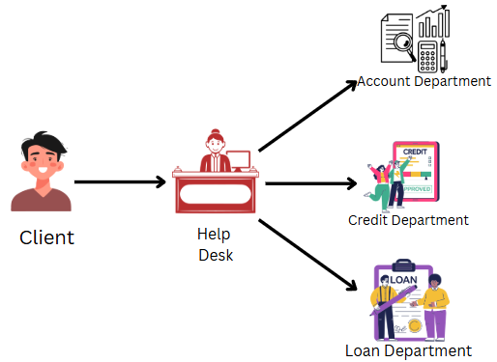

So here in above example, in place of client connecting to every department, we have a help desk and client can just interact with them and get all task done.

Step 1: Subsystem Classes
public class AccountCreation {
public void createAccount(String customer) {
System.out.println("Account created successfully for " + customer);
}
}

public class CreditCheck {
public boolean hasGoodCredit(String customer) {
System.out.println("Checking credit score for " + customer);
return true; // Assume customer has good credit
}
}

public class LoanDepartment {
public void grantLoan(String customer) {
System.out.println("Checking loan history for " + customer);
System.out.println("Loan availed to " + customer);
}
}

Step 2: Façade Class

//Equivalent to help desk
public class BankFacade {
private LoanDepartment loan;
private CreditCheck credit;
private AccountCreation account;
public BankFacade() {
this.loan = new LoanDepartment();
this.credit = new CreditCheck();
this.account = new AccountCreation();
}
public void openAccount(String customer) {
account.createAccount(customer);
if(credit.hasGoodCredit(customer)){
loan.grantLoan(customer);
}else{
System.out.println("Cannot give loan to Customer due to poor credit score");
}
}
}

Step 3: Client Code
public class FacadeClientCode {
public static void main(String[] args) {
BankFacade bank = new BankFacade();
bank.openAccount("Vijay Mallya");
}
}

🔹 When to use Facade Pattern
Scenario | Why Facade Helps
Complex APIs (Multiple Components) | Simplifies client interaction with multiple classes.
Legacy Systems | Provides a modern, easy-to-use interface for old systems.
Microservices Communication | Acts as an entry point to a group of related services.
Third-Party Libraries | Provides consistent API while shielding unnecessary complexity

🔹 Real-World Examples
- Spring JdbcTemplate – Simplifies complex JDBC operations like connection handling, statement creation, execution, and resource cleanup.
- Spring RestTemplate / WebClient – Provides a simplified interface for making HTTP requests.
- JavaMail API Helpers – Simplify email sending by hiding SMTP session configuration.
- SLF4J – Offers a simple logging API while delegating to different logging frameworks.
- Food Delivery Apps – One API coordinates restaurants, payment, delivery, and notifications.
- Banking Systems – A single transaction API manages validation, transfer, logging, and notifications.
- Home Theatre Systems – One button starts multiple entertainment devices.
- Travel Booking Systems – One booking request reserves flights, hotels, and rental cars.

🔹 Adheres to SOLID Principles
- Single Responsibility Principle (SRP): The Facade manages coordination of subsystem interactions, while subsystem classes focus on their own responsibilities.
- Open/Closed Principle (OCP): New subsystem implementations can often be introduced without affecting client code.
- Dependency Inversion Principle (DIP): Clients depend on the Facade abstraction rather than multiple subsystem implementations.

3. Decorator Pattern
The Decorator Pattern is a structural design pattern that adds new behaviours to objects dynamically without modifying their existing code. Instead of extending a class through inheritance, it relies on composition to wrap objects with additional functionality.

🔹Intent of Decorator Pattern
- Allows adding new functionalities to an object at runtime.
- Avoids subclass explosion caused by multiple feature combinations.
- Uses wrappers instead of modifying the base class directly.
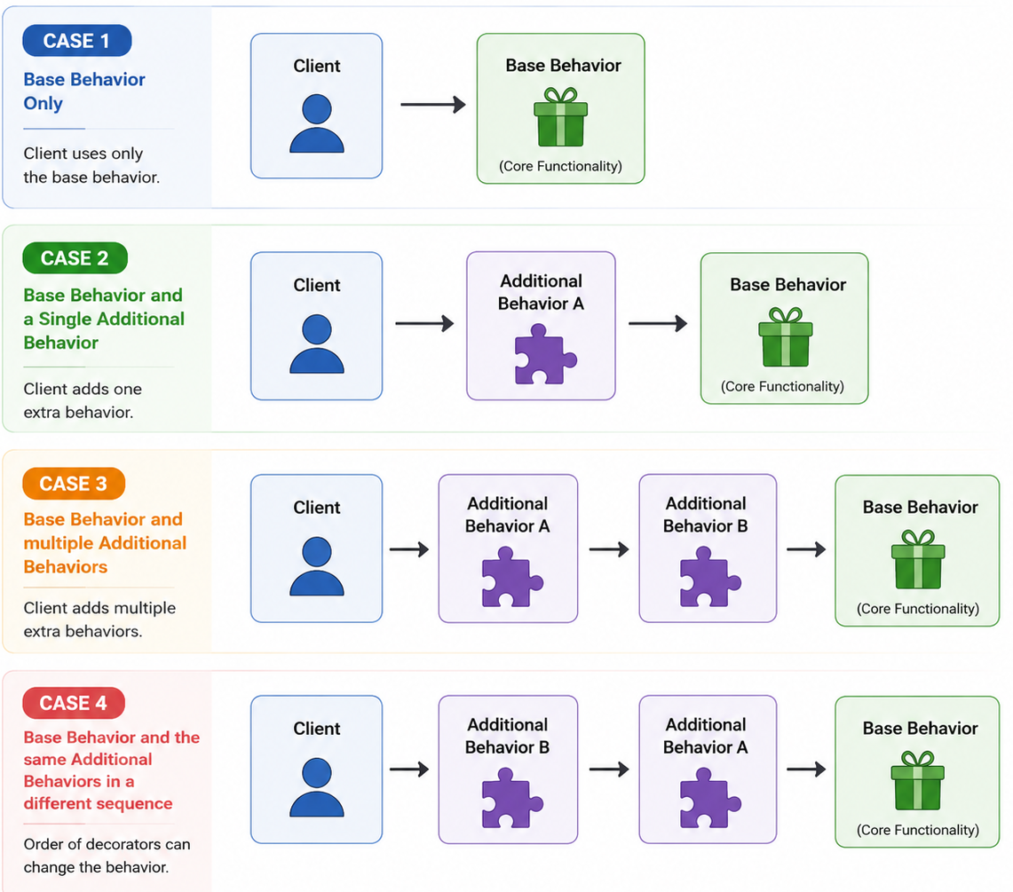
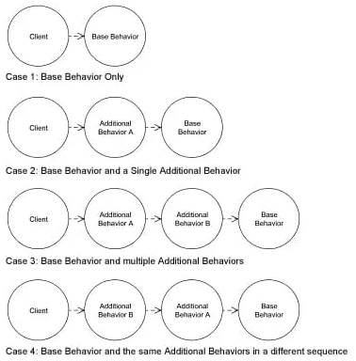

- In the Decorator pattern, decorators wrap original objects, adding new behaviour or responsibilities without altering the original object's code.
- Decorator classes implement the same interface as the components they enhance, allowing clients to use both interchangeably.
- The Decorator pattern allows you to extend an object's functionality at runtime without altering its structure, enabling dynamic behaviour enhancements
🔹 Implementation with Decorator Pattern
A coffee shop offers different types of coffee. Customers can add milk, sugar, whipped cream, or vanilla flavour. The price should dynamically update based on the selected add-ons.

Step 1: Define the Base Component
// Component Interface
interface Coffee {
String getDescription();
double getCost();
}

Step 2: Implement a Basic Coffee Class
// Concrete Component: Basic coffee
class BasicCoffee implements Coffee {
@Override
public String getDescription() {
return "Basic Coffee";
}
// Base price
@Override
public double getCost() {
return 50;
}
}

Step 3: Create an Abstract Decorator
// Abstract Decorator
abstract class CoffeeDecorator implements Coffee {
protected Coffee coffee;
public CoffeeDecorator(Coffee coffee) {
this.coffee = coffee;
}
@Override
public String getDescription() {
return coffee.getDescription();
}
@Override
public double getCost() {
return coffee.getCost();
}
}
Step 4: Implement Add-On Decorators
class Sugar extends CoffeeDecorator { // Concrete Decorator: Adds Sugar
public Sugar(Coffee coffee) {
super(coffee);
}
@Override
public String getDescription() {
return coffee.getDescription() + ", Sugar";
}
@Override
public double getCost() {
return coffee.getCost() + 5;
}
}

// Concrete Decorator: Adds Whipped Cream
class WhippedCream extends CoffeeDecorator {
public WhippedCream(Coffee coffee) {
super(coffee);
}
@Override
public String getDescription() {
return coffee.getDescription() + ", Whipped Cream";
}
@Override
public double getCost() {
return coffee.getCost() + 15;
}
}

Step 5: Client code
public class CoffeeShop {
public static void main(String[] args) {
Coffee coffee = new BasicCoffee();
System.out.println(coffee.getDescription() + " = $" + coffee.getCost());
coffee = new Milk(coffee);
coffee = new Sugar(coffee);
System.out.println(coffee.getDescription() + " = $" + coffee.getCost());
coffee = new WhippedCream(coffee);
System.out.println(coffee.getDescription() + " = $" + coffee.getCost());
}
}
Output:
Basic Coffee = $50.0
Basic Coffee, Milk, Sugar = $65.0
Basic Coffee, Milk, Sugar, Whipped Cream = $80.0

🔹 Real-World Examples
- Java I/O Streams – BufferedInputStream, DataInputStream, and CheckedInputStream wrap another stream to add buffering, data reading, or checksum functionality.
- Spring Security Filters – Multiple filters wrap and enhance request processing with authentication, authorization, and logging.
- Java Collections (Collections.synchronizedList()) – Wraps a list to add thread safety without changing the original implementation.
- Coffee Shop Applications – Add milk, chocolate, whipped cream, or caramel to a base coffee.
- Text Editors – Apply bold, italic, underline, or highlighting dynamically.
- Pizza Ordering Systems – Stack toppings over a base pizza.
- Logging Frameworks – Add timestamps, encryption, or formatting around log messages.
- Compression & Encryption Pipelines – Wrap streams with compression and encryption decorators.

🔹 Adheres to SOLID Principles
- Single Responsibility Principle (SRP): Each decorator adds one specific responsibility (e.g., milk, chocolate, buffering).
- Open/Closed Principle (OCP): New behaviours are added by creating new decorators without modifying existing classes.
- Dependency Inversion Principle (DIP): Clients depend on the Coffee abstraction rather than concrete implementations.

4. Proxy Pattern
The Proxy Pattern is a structural design pattern that provides a surrogate or placeholder for another object to control access to it. The proxy acts as an intermediary between the client and the real object, adding functionalities like security, logging, caching, or lazy initialization without modifying the original object.

🔹Intent of Decorator Pattern
- Controls access to an object based on certain conditions (e.g., authentication, permissions).
- Adds lazy initialization for resource-intensive objects.
- Implements logging, caching, and request filtering.
- Protects the real object from direct access.

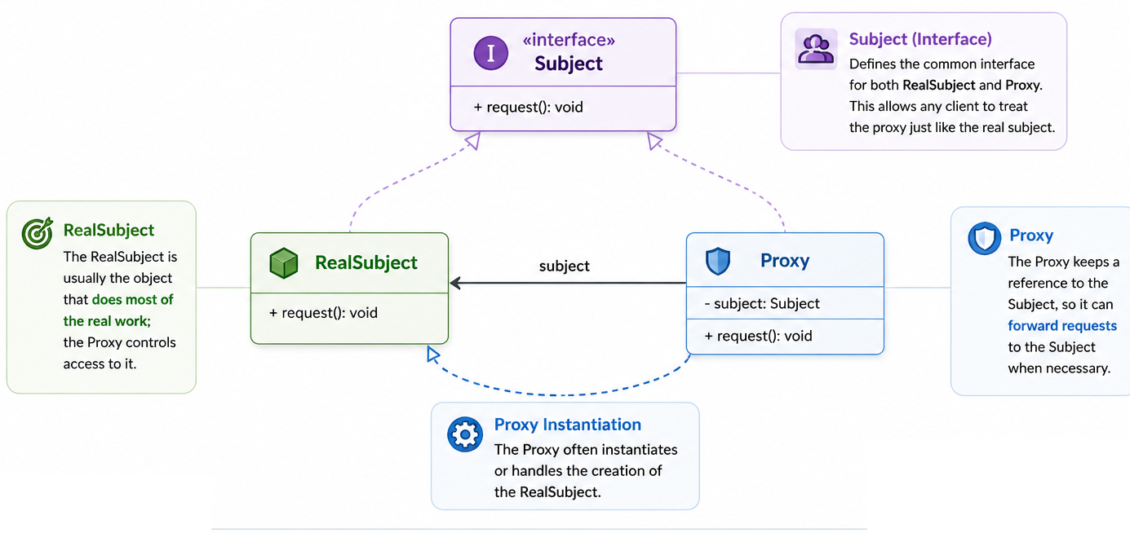
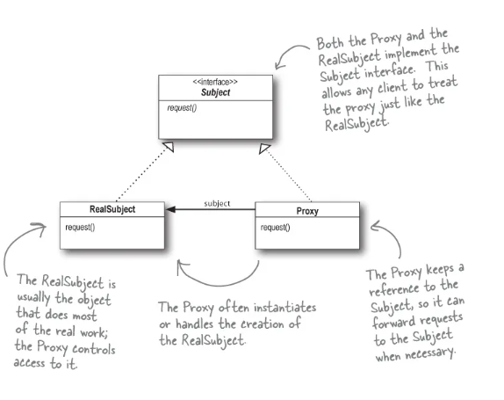

🔹 Implementation with Proxy Pattern
Imagine an application that loads high-resolution images. Instead of loading the image immediately, a proxy delays loading until it's actually needed (Lazy initialization).
Step 1: Define a common interface
// Subject interface
interface Image {
void display();
}

Step 2: Implement a Real Object
// Real Object that loads and displays an image
class RealImage implements Image {
private String fileName;
public RealImage(String fileName) {
this.fileName = fileName;
loadFromDisk(); //Heavy operation
}
private void loadFromDisk() {
System.out.println("Loading image: " + fileName);
}
@Override
public void display() {
System.out.println("Displaying image: " + fileName);
}
}

Step 3: Create a Proxy Object
// Proxy class that controls access to RealImage
// Implements same interface as real object
class ProxyImage implements Image {
private RealImage realImage;
private String fileName;
public ProxyImage(String fileName) {
this.fileName = fileName;
}
@Override
public void display() {
if (realImage == null) { //Lazy Loading
realImage = new RealImage(fileName); // Load only when needed
}
realImage.display();
}
}

Step 4: Client Code
public class ProxyPatternDemo {
public static void main(String[] args) {
Image image1 = new ProxyImage("photo1.jpg");
Image image2 = new ProxyImage("photo2.jpg");
// Image is loaded only when display() is called
image1.display();
System.out.println("------");
image1.display(); // This time it is not loaded again
//Since image2 is never displayed, it is never loaded
}
}

🔹When and where to use Proxy Pattern
Scenario | Why Proxy Helps
Restrict access to a resource | Ensures only authorized users can access the object.
Lazy Initialization | Delays object creation until it's actually needed (e.g., large database connections).
Logging & Monitoring | Keeps track of actions performed on the object.
Caching | Stores previous results to optimize performance.

🔹Adheres to SOLID Principles:
- Single Responsibility Principle (SRP): The proxy manages access, while the real object focuses on business logic.
- Open/Closed Principle (OCP): New proxy behaviours (logging, security, caching) can be added without modifying the real object.
- Dependency Inversion Principle (DIP): Clients depend on the common Image interface rather than concrete implementations.

5. Composite Pattern
The Composite Pattern is a structural design pattern that lets you compose objects into tree-like structures to represent part-whole hierarchies. It treats individual objects and compositions of objects uniformly.

🔹Intent of Composite Pattern
- Allows clients to interact with individual objects and composite objects in the same way.
- Provides a tree structure to represent complex hierarchies.
- The Composite pattern allows clients to treat individual objects and compositions of objects uniformly, often useful for hierarchical structures like trees.

❌ Without Composite Pattern (File Management system)
public class File {
private String name;
public File(String name){
this.name = name;
}
public void showDetails(){
System.out.println("File : " +name);
}
}

public class Folder {
private String name;
private List<File> files = new ArrayList<>();
public Folder(String name){
this.name = name;
}
public void addFile(File file){
files.add(file);
}
public void showDetails(){
System.out.println("Folder: " + name);
for(File file:files){
file.showDetails();
}
}
}
Client code:
public class FileSystemApp {
public static void main(String[] args) {
File file1 = new File("File1.txt");
File file2 = new File("File2.txt");
Folder folder = new Folder("Documents");
folder.addFile(file1);
folder.addFile(file2);
folder.showDetails();
}
}
Tough to add nested folder, will need to modify code a lot.

🔹 Implementation with Composite Pattern
Issue with above code: For file system we can also have scenarios where we can have sub-folders. To handle that case in above code we will have to write complex if-else conditions. But with Composite pattern, both Files and Folder will be treated uniformly and will implement same interface

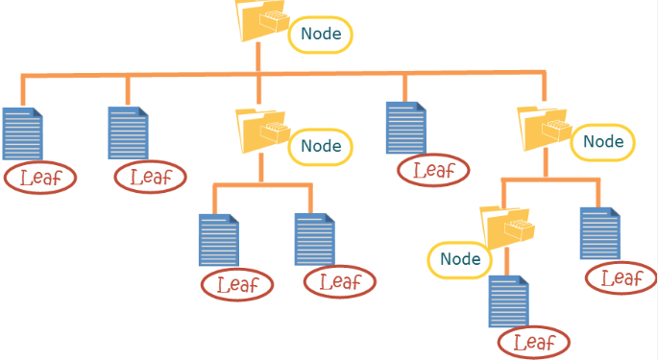

Step 1: Define a common interface
// Component Interface
interface FileSystemComponent {
void showDetails();
}

Step 2: Implement Leaf class (File)
// Leaf: File (does not contain other components)
class File implements FileSystemComponent {
private String name;
public File(String name) {
this.name = name;
}
@Override
public void showDetails() {
System.out.println("File: " + name);
}
}

Step 3: Implement Composite Class(Folder)
import java.util.ArrayList;
import java.util.List;
// Composite: Folder (can contain files and other folders)
class Folder implements FileSystemComponent {
private String name;
private List<FileSystemComponent> components = new ArrayList<>();
public Folder(String name) {
this.name = name;
}
public void addComponent(FileSystemComponent component) {
components.add(component);
}
@Override
public void showDetails() { // DFS (recursive function)
System.out.println("Folder: " + name);
for (FileSystemComponent component : components) {
component.showDetails();
}
}
}
Step 4: Client Code

public class CompositePatternDemo {
public static void main(String[] args) {
FileSystemComponent file1 = new File("document.txt");
FileSystemComponent file2 = new File("photo.jpg");
Folder folder1 = new Folder("My Documents");
folder1.addComponent(file1);
folder1.addComponent(file2);
FileSystemComponent file3 = new File("notes.txt");
Folder rootFolder = new Folder("Root");
rootFolder.addComponent(folder1);
rootFolder.addComponent(file3);
rootFolder.showDetails();
}
}

Output:
Folder: Root
Folder: My Documents
File: document.txt
File: photo.jpg
File: notes.txt

🔹When and Where to use Composite Pattern
Scenario | Why Composite Helps
File System (Folders & Files) | Both files and folders should be handled in the same way.
Organization Hierarchy | Employees, managers, and departments should be processed uniformly.
UI Components (Buttons, Panels, Containers) | Allows nesting of UI components inside one another.

6. Flyweight Pattern
The Flyweight Pattern is a structural design pattern used to minimize memory usage and increase performance by sharing common object states instead of creating new ones.

🔹 Intent of Flyweight Pattern
- Reduces memory consumption by storing shared objects instead of creating duplicates.
- Increases application performance and efficiency.
- Separates intrinsic state (shared) from extrinsic state (unique per instance).
- Ideal for working with a large number of similar objects.

🔹 Implementation of Flyweight Pattern

Image a scenario of creating game like Flappy Bird.
In Flappy Bird, multiple pillars (pipes) are continuously generated as obstacles. Each pillar has:
- A common image texture (intrinsic state) 🎨
- A unique position and height (extrinsic state) 📏
Instead of creating a new pillar object every time, we use the Flyweight Pattern to share the pillar image while keeping position and height unique.



Step 1: Flyweight Class (Shared State - Pillar Image)

// Flyweight Class: Shared pillar image
class Pillar {
private final String image; // Heavy resource (shared)
public Pillar(String image) {
this.image = image;
}
public void draw(int x, int height) {
System.out.println("Drawing pillar at X: " + x + " with height: " + height + " using image: " + image);
}
}

Step 2: Flyweight Factory (Manages Shared Objects)

// Factory Class: Reuses pillar images
class PillarFactory {
private static final Map<String, Pillar> pillarMap = new HashMap<>();
public static Pillar getPillar(String image) {
if (!pillarMap.containsKey(image)) {
pillarMap.put(image, new Pillar(image));
System.out.println("Loading new Pillar Image: " + image);
}
return pillarMap.get(image);
}
}

Step 3: Context Class (Stores Unique State - Position & Height)
class GamePillar {
private final int x;
private final int height;
private final Pillar pillar;
public GamePillar(int x, int height, Pillar pillar) {
this.x = x;
this.height = height;
this.pillar = pillar;
}
public void render() {
pillar.draw(x, height);
}
}

Step 4: Client Code (Creates Pillars Efficiently)
import java.util.ArrayList;
import java.util.List;
public class FlyweightGameDemo {
public static void main(String[] args) {
List<GamePillar> pillars = new ArrayList<>();
// Shared image for pillars
Pillar sharedPillar = PillarFactory.getPillar("FlappyPillar.png");
// Creating multiple pillars with unique positions and heights
pillars.add(new GamePillar(100, 300, sharedPillar));
pillars.add(new GamePillar(250, 400, sharedPillar));
pillars.add(new GamePillar(400, 350, sharedPillar));
pillars.add(new GamePillar(550, 450, sharedPillar)); // Reuses the same image
// Rendering pillars
for (GamePillar pillar : pillars) {
pillar.render();
}
}
}

🔹 When to use Flyweight Pattern
Scenario |  | Why Flyweight Helps
Large Number of Objects | Avoids memory overhead by sharing common data.
Rendering Systems | Optimizes repeated elements like fonts, text characters, icons, etc.
String Pooling | Reuses immutable string objects to save memory.
Game Development | Optimizes character models, trees, bullets, and objects in large scenes.
Text Editors | Shares character objects instead of creating new ones for each letter.

🔹 Adheres to SOLID Principles
- Single Responsibility Principle (SRP): Flyweight objects manage shared state, while clients manage unique state.
- Open/Closed Principle (OCP): New flyweight types can be added without changing existing clients.
- Dependency Inversion Principle (DIP): Clients depend on the ChessPiece abstraction instead of concrete implementations.

7. Bridge Pattern
The Bridge Pattern is a structural design pattern that decouples an abstraction from its implementation, allowing the two to vary independently.

🔹 When to use the Bridge Pattern
- When you have a hierarchy in abstraction (e.g., different types of players).
- And a hierarchy in implementation (e.g., different types of operating systems or formats).
- To avoid a Cartesian explosion of subclasses (e.g., VideoPlayerOnWindows, AudioPlayerOnLinux, VideoPlayerOnLinux... etc.).

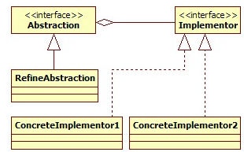

🔹Implementation of Bridge Pattern

Design Goal: A system where you can easily plug in different media players (audio, video) and types (basic, premium, advanced).
Use the Bridge pattern to connect MediaPlayerType with MediaType
- Abstraction: Player Type (Basic, Advanced, Premium)
- Implementation: Media Type (Audio, Video, Streaming)
This keeps both independent and extensible.

🔹What happens if we don’t use Bridge Pattern

You will end up creating a class for each combination, like:
- BasicAudioPlayer, BasicVideoPlayer, AdvancedVideoPlayer, PremiumAudioStreamingPlayer, etc.
- Violates Open/Closed Principle – hard to extend.
- Leads to class explosion (redundant + unmanageable).
Without Bridge Pattern

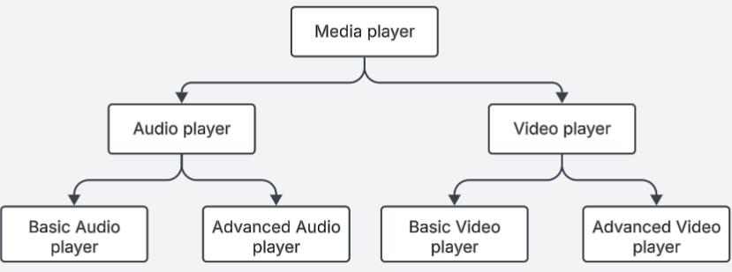

With Bridge Pattern

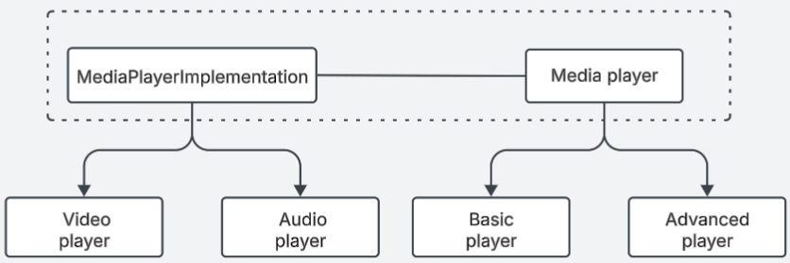

🔹 Code
Step 1: Implementer Interface

// Implementor
interface MediaPlayerImplementation {
void playFile(String filename);
}

Step 2: Concrete Implementations

// Concrete Implementor 1
class AudioPlayerImplementation implements MediaPlayerImplementation {
public void playFile(String filename) {
System.out.println("Playing audio file: " + filename);
}
}
// Concrete Implementor 2
class VideoPlayerImplementation implements MediaPlayerImplementation {
public void playFile(String filename) {
System.out.println("Playing video file: " + filename);
}
}

Step 3: Abstraction

// Abstraction
abstract class MediaPlayer {
protected MediaPlayerImplementation implementation;
public MediaPlayer(MediaPlayerImplementation implementation) {
this.implementation = implementation;
}
public abstract void play(String filename);
}

Step 4: Refined Abstraction

// Refined Abstraction
class BasicPlayer extends MediaPlayer {
public BasicPlayer(MediaPlayerImplementation implementation) {
super(implementation);
}
public void play(String filename) {
System.out.println("Basic Player Delegating...");
implementation.playFile(filename);
}
}
class AdvancedPlayer extends MediaPlayer {
public AdvancedPlayer(MediaPlayerImplementation implementation) {
super(implementation);
}
public void play(String filename) {
System.out.println("Advanced Player with Equalizer & Subtitles...");
implementation.playFile(filename);
}
}

Step 5: Client Code
public class BridgePatternDemo {
public static void main(String[] args) {
MediaPlayerImplementation audioImpl = new AudioPlayerImplementation();
MediaPlayerImplementation videoImpl = new VideoPlayerImplementation();
MediaPlayer basicAudioPlayer = new BasicPlayer(audioImpl);
MediaPlayer advancedVideoPlayer = new AdvancedPlayer(videoImpl);
basicAudioPlayer.play("song.mp3");
advancedVideoPlayer.play("movie.mp4");
}
}

🔹 Real-World Examples:
- Java JDBC – The JDBC API (abstraction) works with different database drivers (implementations) like MySQL, PostgreSQL, and Oracle.
- SLF4J – A common logging API bridges to Logback, Log4j, or JUL implementations.
- Spring JdbcTemplate – Uses the same abstraction while interacting with different JDBC drivers.
- Remote Controls – One remote interface works with multiple TV brands.
- Graphics Libraries – Shapes are separated from rendering APIs like OpenGL or DirectX.

🔹 Adheres to SOLID Principles:
- Single Responsibility Principle (SRP): The abstraction (Remote) manages user operations, while the implementation (TV) manages device-specific behaviour.
- Open/Closed Principle (OCP): New remotes or TV brands can be added without modifying existing classes.
- Dependency Inversion Principle (DIP): The abstraction depends on the TV interface rather than concrete TV implementations.

Behavioural Design Patterns

1. Strategy Pattern
The Strategy Pattern defines a family of algorithms, encapsulates each one, and makes them interchangeable. Strategy lets the algorithm vary independently from the clients that use it.
Intent: To enable selecting an algorithm's behaviour at runtime. It promotes the use of composition over inheritance.

🔹 Key Points
Aspect | Detail
Problem Solved | Avoids conditional logic for algorithm selection
Type | Behavioural Pattern
Principle | Adheres to Open/Closed and Single Responsibility principles
Composition | Uses composition to switch between algorithms dynamically
Clients | Can use different strategies without changing their own code

🔹 Real-World Examples: Payment System

❌Without Strategy Pattern (Direct Instantiation)

if (paymentType.equals("card")) {
// process card
} else if (paymentType.equals("paypal")) {
// process PayPal
} ...
- Violates Open/Closed
- Not Scalable
- Difficult to maintain
- Hard to test
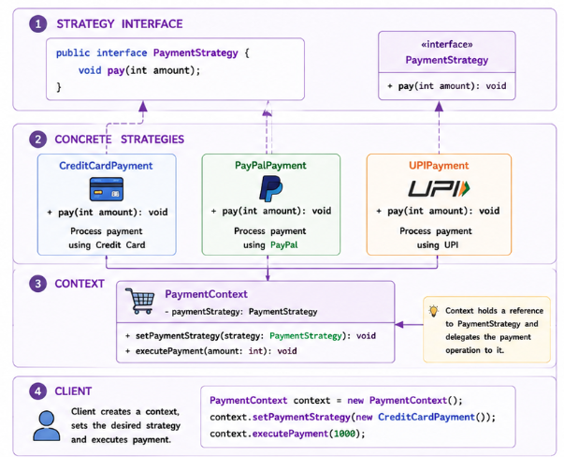
🔹 Implementation with Strategy Pattern

Step1: Strategy Interface
public interface PaymentStrategy {
void pay(int amount);
}

Step2: Concreate Strategies
public class CreditCardPayment implements PaymentStrategy {
private String cardNumber;
public CreditCardPayment(String cardNumber) {
this.cardNumber = cardNumber;
}
@Override
public void pay(int amount) {
System.out.println("Paid ₹" + amount + " using Credit Card ending with " + cardNumber.substring(cardNumber.length() - 4));
}
}

public class PayPalPayment implements PaymentStrategy {
private String email;
public PayPalPayment(String email) {
this.email = email;
}
@Override
public void pay(int amount) {
System.out.println("Paid ₹" + amount + " using PayPal account: " + email);
}
}

public class UPIPayment implements PaymentStrategy {
private String upiId;
public UPIPayment(String upiId) {
this.upiId = upiId;
}
@Override
public void pay(int amount) {
System.out.println("Paid ₹" + amount + " using UPI ID: " + upiId);
}
}

Step3: Context Class
public class PaymentContext {
private PaymentStrategy strategy;
public PaymentContext(PaymentStrategy strategy) {
this.strategy = strategy;
}
public void setPaymentStrategy(PaymentStrategy strategy) {
this.strategy = strategy;
}
public void payAmount(int amount) {
strategy.pay(amount);
}
}

Step4: Client Code
public class StrategyPatternDemo {
public static void main(String[] args) {
PaymentContext context = new PaymentContext(new CreditCardPayment("1234567890123456"));
context.payAmount(1000);
//Can change payment strategy at runtime
context.setPaymentStrategy(new PayPalPayment("john@example.com"));
context.payAmount(500);
context.setPaymentStrategy(new UPIPayment("john@upi"));
context.payAmount(750);
}
}

🔹 Real-World Examples:
- Sorting Algorithms: Java’s Collections.sort() or Python’s sorted() use different sorting strategies depending on the size and nature of data.
List<Integer> numbers = Arrays.asList(5, 2, 9, 1);
Collections.sort(numbers); // Strategy chosen internally
- Payment Gateways: Apps like Amazon, Flipkart allow users to choose payment options dynamically — UPI, Cards, Wallets.
- Compression Tools: ZIP, RAR, TAR — all can be interchangeable strategies to compress files.

🔹 Adheres to SOLID Principles:
- Single Responsibility Principle: Each strategy has one job — implement one algorithm.
- Open/Closed Principle: New strategies can be introduced without modifying context.
- Dependency Inversion Principle: Context depends on abstractions (PaymentStrategy), not concrete implementations.

2. Command Pattern
The Command Pattern is a behavioural design pattern that turns a request into a standalone object containing all the information about the request. This allows you to parameterize methods with different requests, queue them, log them, and support undo/redo operations.
Intent: Encapsulate a request as an object, thereby letting you parameterize clients with queues, requests, and operations.

🔹 Key Points
Aspect | Detail
Problem Solved | Decouples invoker from receiver
Type | Behavioural Pattern
Principle | Encapsulates a request as an object
Flexibility | Easily supports macro commands, queuing, logging, and transaction-based actions.
Best Used | When multiple actions(commands) are performed on system

🔹 Real-World Example: Remote control for Fan and Light
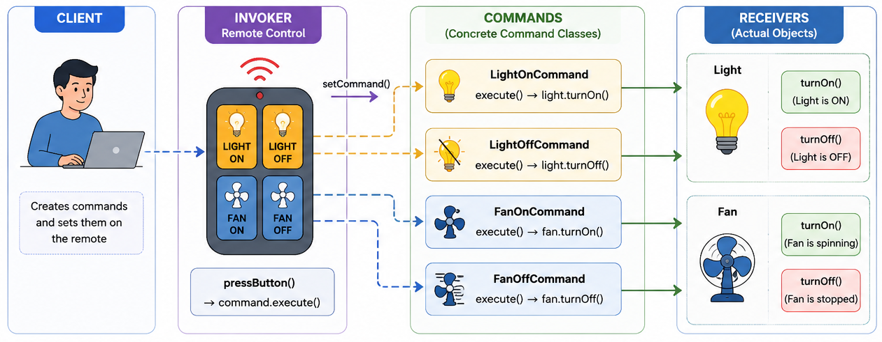

Step 1: Command Interface

public interface Command {
void execute();
}

Step 2: Receivers (Light & Fan)

public class Light {
public void turnOn() {
System.out.println("Light is ON");
}
public void turnOff() {
System.out.println("Light is OFF");
}
}

public class Fan {
public void turnOn() {
System.out.println("Fan is spinning");
}
public void turnOff() {
System.out.println("Fan is stopped");
}
}

Step 3: Concrete Command Class

public class LightOnCommand implements Command {
private Light light;
public LightOnCommand(Light light) {
this.light = light;
}
public void execute() {
light.turnOn();
}
}

public class LightOffCommand implements Command {
private Light light;
public LightOffCommand(Light light) {
this.light = light;
}
public void execute() {
light.turnOff();
}
}

public class FanOnCommand implements Command {
private Fan fan;
public FanOnCommand(Fan fan) {
this.fan = fan;
}
public void execute() {
fan.turnOn();
}
}

public class FanOffCommand implements Command {
private Fan fan;
public FanOffCommand(Fan fan) {
this.fan = fan;
}
public void execute() {
fan.turnOff();
}
}

Step 4: Invoker (Remote Control)
public class RemoteControl {
private Command command;
public void setCommand(Command command) {
this.command = command;
}
public void pressButton() {
command.execute();
}
}
Step 5: Client Code
public class CommandPatternDemo {
public static void main(String[] args) {
Light light = new Light(); // Create receivers
Fan fan = new Fan();
Command lightOn = new LightOnCommand(light); // Create commands
Command lightOff = new LightOffCommand(light);
Command fanOn = new FanOnCommand(fan);
Command fanOff = new FanOffCommand(fan);
RemoteControl remote = new RemoteControl(); // Create remote
remote.setCommand(lightOn); // Control Light
remote.pressButton(); // Output: Light is ON
remote.setCommand(lightOff);
remote.pressButton(); // Output: Light is OFF
remote.setCommand(fanOn); / Control Fan
remote.pressButton(); // Output: Fan is spinning
remote.setCommand(fanOff);
remote.pressButton(); // Output: Fan is stopped
}
}

🔹 Importance of Command Pattern
- Extensible – Add new commands without changing existing code.
- Flexible – Can create macro commands (e.g., morning routine).
- Undo/Redo – Keeps history for powerful features.
- Decoupling – Invoker doesn’t need to know the implementation.

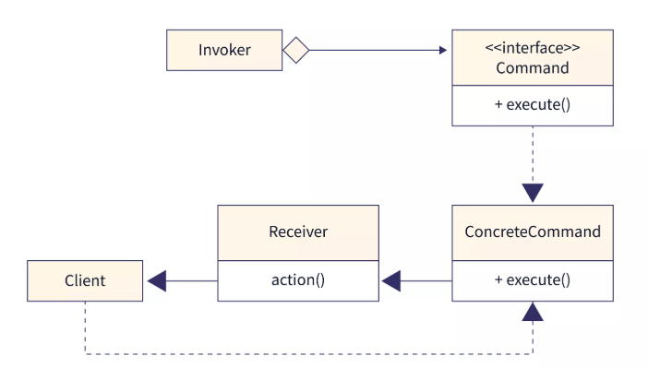
🔹 Real-World Examples:
- Think of a text editor like VSCode:
  - Typing, deleting, and formatting are actions (commands).
  - You can undo/redo these because each action is stored as a Command object with its execution and un-execution logic.
- Smart Home Automation Systems
  - Each action (turning lights, setting thermostat) becomes a command.
  - Allows scheduling, undoing, and remote triggering.
- Transaction Processing in Banking
  - Each transaction (deposit, withdraw) is encapsulated in a command.
  - Enables rollback in case of failure (undo).
- Game Controls
  - Moves and actions are commands.
  - You can replay (macro), undo, or bind new actions dynamically.

🔹 Adheres to SOLID Principles:
- Single Responsibility Principle: Each Command has one job — implement one action.
- Open/Closed Principle: New commands can be introduced without modifying context.
- Dependency Inversion Principle: Client depends on invoker to perform any action.

3. Chain of Responsibility Pattern
The Chain of Responsibility (CoR) Pattern allows a request to pass through a chain of handlers. Each handler decides whether it can process the request. If it cannot, it forwards the request to the next handler in the chain.

Intent: To decouple the sender of a request from its receivers by giving multiple objects a chance to handle the request.

🔹 Key Points
Aspect | Detail
Problem Solved | Avoid multiple if else or switch statements for handling requests
Type | Behavioural Pattern
Principle | Adheres to Open/Closed and Single Responsibility principles
Flexibility | Handlers can be added, removed or reordered easily
Processing | Request travels through chain until a handler processes it.

🔹 Real-World Examples: Customer Support System

❌Without Chain of Responsibility Pattern (Direct Instantiation)
if(ticketType.equals("BILLING")){
// Handle billing issue
}
else if(ticketType.equals("TECHNICAL")){
// Handle technical issue
}
else if(ticketType.equals("ACCOUNT")){
// Handle account issue
}
else{
// Unknown issue
}

- Violates Open/Closed
- Large if-else chains
- Difficult to maintain and extend
- Tight coupling between sender and handlers
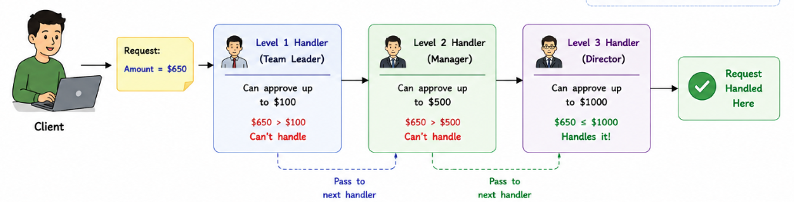
🔹 Implementation with Chain of Responsibility Pattern

- Each handler decides either to handle the request or pass it to next handler.
- Handlers are linked in a chain.
- Request goes until it is handled or the end of the chain.

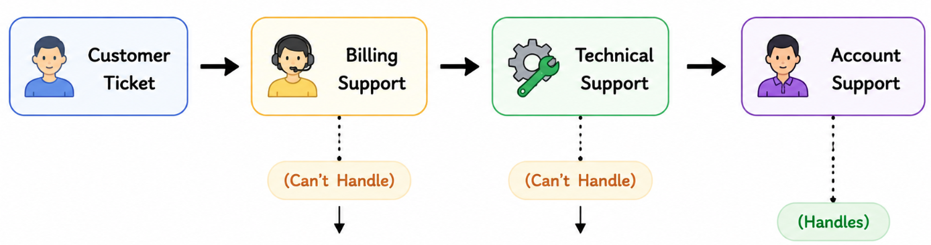
Customer Support System

Step1: Request Class
public class SupportTicket {
private String type;
private String issue;
public SupportTicket(String type, String issue) {
this.type = type;
this.issue = issue;
}
public String getType() {
return type;
}
public String getIssue() {
return issue;
}
}
Step2: Abstract Handler

public abstract class SupportHandler {
protected SupportHandler nextHandler;
public void setNextHandler(SupportHandler nextHandler) { //method for chaining
this.nextHandler = nextHandler;
}
public abstract void handleRequest(SupportTicket ticket);
}

Step3: Concrete Handlers
//does not containing chaining code here
//just handles the request
public class BillingSupport extends SupportHandler {
@Override
public void handleRequest(SupportTicket ticket) {
if(ticket.getType().equalsIgnoreCase("BILLING")){
System.out.println("Billing Team resolved: " + ticket.getIssue());
}
else if(nextHandler != null){
nextHandler.handleRequest(ticket);
}
}
}

public class TechnicalSupport extends SupportHandler {
@Override
public void handleRequest(SupportTicket ticket) {
if(ticket.getType().equalsIgnoreCase("TECHNICAL")){
System.out.println("Technical Team resolved: " + ticket.getIssue());
}
else if(nextHandler != null){
nextHandler.handleRequest(ticket);
}
}
}

public class AccountSupport extends SupportHandler {
@Override
public void handleRequest(SupportTicket ticket) {
if(ticket.getType().equalsIgnoreCase("ACCOUNT")){
System.out.println("Account Team resolved: " + ticket.getIssue());
}
else if(nextHandler != null){
nextHandler.handleRequest(ticket);
}
else{
System.out.println("No handler available for this request.");
}
}
}

Step4: Client Code
public class ChainPatternDemo {
public static void main(String[] args) {
SupportHandler billing = new BillingSupport();
SupportHandler technical = new TechnicalSupport();
SupportHandler account = new AccountSupport();
//Contains logic for chaining
billing.setNextHandler(technical);
technical.setNextHandler(account);
billing.handleRequest(new SupportTicket(
"TECHNICAL",
"Unable to login"));
billing.handleRequest(new SupportTicket(
"ACCOUNT",
"Update email address"));
billing.handleRequest(new SupportTicket(
"BILLING",
"Refund not received"));
billing.handleRequest(new SupportTicket(
"OTHER",
"Unknown issue"));
}
}

🔹 Real-World Examples:
- Customer Support Systems – Billing → Technical → Account → Manager.
- ATM Cash Dispensing – ₹2000 → ₹500 → ₹100 note dispensers.
- Java Servlet Filters – Authentication → Logging → Compression → Request Processing.
- Spring Security Filter Chain – Authentication, Authorization, CSRF, Session Management, etc.
- Logging Frameworks – Log4j, SLF4J, Java Util Logging.
- Approval Workflows – Employee → Manager → Director → CEO.
- Exception Handling Pipelines – Multiple exception handlers process an exception.

🔹 Adheres to SOLID Principles:
- Single Responsibility Principle (SRP): Each handler has only one responsibility.
- Open/Closed Principle (OCP): New handlers can be added without modifying existing ones.
- Dependency Inversion Principle (DIP): Client depends on the abstract SupportHandler, not concrete handlers.

🔹 Advantages:
- Removes large if-else or switch statements.
- Sender doesn't know who will handle the request.
- Easy to add new handlers.
- Handlers are loosely coupled.
- Order of handlers can be changed dynamically.
- Supports runtime configuration of the processing chain.

🔹 When to Use:
- Multiple objects can handle the same request.
- The exact handler is determined at runtime.
- You want to eliminate long if-else or switch statements.
- The sender should not know which object processes the request.
- You want a flexible and extensible processing pipeline.

4. Interpreter Pattern
The Interpreter Pattern defines a representation for a language's grammar and provides an interpreter to evaluate sentences in that language. Each grammar rule is represented as a class, allowing expressions to be interpreted recursively.

Intent: To define a grammar for a language and provide an interpreter that can evaluate expressions written in that language.

🔹 Key Points
Aspect | Detail
Problem Solved | Evaluates expression based on predefined grammar
Type | Behavioural Pattern
Principle | Represent grammar rules using separate classes
Structure | Use recursive composition of expressions
Best Used | Mathematical Expressions, SQL parsers, compilers, rule engines

🔹 Real-World Examples: Access Control Rules
Suppose an application allows administrators to define access rules like: ADMIN and ACTIVE or ADMIN or MANAGER.

❌Without Interpreter Pattern (Direct Instantiation)
if(user.hasRole("ADMIN") && user.isActive()){
// Grant Access
}
else if(user.hasRole("ADMIN") || user.hasRole("MANAGER")){
// Grant Access
}
else if(...){
...
}

- Difficult to add new rules
- Large if-else chains
- Business rules scattered throughout the code
- Violates Open/Closed Principle
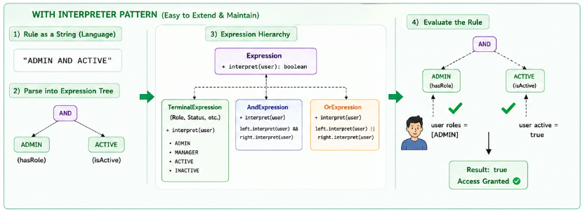
🔹 Implementation with Interpreter Pattern

- Define a language: Rules written using operators like and, or
- Build Expression tree: rule is parsed into tree of objects
- Interpret : Tree is evaluated against a user to produce a result

Step1: Context Class

import java.util.Set;
public class User {
private Set<String> roles;
public User(Set<String> roles) {
this.roles = roles;
}
public boolean hasRole(String role) {
return roles.contains(role);
}
}

Step2: Expression Interface

public interface Expression {
boolean interpret(User user);
}

Step3: Terminal Expression
public class RoleExpression implements Expression {
private String role;
public RoleExpression(String role) {
this.role = role;
}
@Override
public boolean interpret(User user) {
return user.hasRole(role);
}
}

Step4: Non-Terminal Expressions
public class AndExpression implements Expression {
private Expression expression1;
private Expression expression2;
public AndExpression(Expression expression1, Expression expression2) {
this.expression1 = expression1;
this.expression2 = expression2;
}
@Override
public boolean interpret(User user) {
return expression1.interpret(user) && expression2.interpret(user);
}
}

public class OrExpression implements Expression {
private Expression expression1;
private Expression expression2;
public OrExpression(Expression expression1,Expression expression2) {
this.expression1 = expression1;
this.expression2 = expression2;
}
@Override
public boolean interpret(User user) {
return expression1.interpret(user) || expression2.interpret(user);
}
}

Step5: Client Code
import java.util.Set;
public class InterpreterPatternDemo {
public static void main(String[] args) {
Expression admin = new RoleExpression("ADMIN");
Expression manager = new RoleExpression("MANAGER");
Expression adminOrManager = new OrExpression(admin, manager);
User user = new User(Set.of("MANAGER"));
System.out.println(adminOrManager.interpret(user)); //true
}
}

🔹 Real-World Examples:
- SQL Query Parsers – Parse and interpret SQL statements.
- Mathematical Expression Evaluators – 10 + 20 * 5.
- Rule Engines – Business rule evaluation.
- Regular Expression Engines – Pattern matching.
- Search Query Parsers – Google search, Elasticsearch.
- Compilers and Interpreters – JavaScript, Python interpreters.
- Access Control Systems – Role and permission evaluation.

🔹 Adheres to SOLID Principles:
- Single Responsibility Principle (SRP): Each expression class interprets only one grammar rule.
- Open/Closed Principle (OCP): New expressions can be added without modifying existing ones.
- Dependency Inversion Principle (DIP): Client depends on the Expression abstraction instead of concrete implementations.

🔹 When to Use:
- You need to evaluate expressions based on a well-defined grammar.
- The grammar is relatively simple and unlikely to change frequently.
- Expressions can be represented as a tree of objects.
- You are building parsers, rule engines, calculators, or query evaluators.
- You want to represent grammar rules using object-oriented design.

5. Iterator Pattern
The Iterator Pattern provides a way to access the elements of a collection sequentially without exposing its underlying representation. It allows traversal of a collection while keeping the collection's internal structure hidden.

Intent: To provide a standard way to traverse elements of a collection without exposing its internal implementation.

🔹 Key Points
Aspect | Detail
Problem Solved | Traverses collections without exposing internal structure
Type | Behavioural Pattern
Principle | Separates traversal logic from collection logic
Flexibility | Different traversal algos can be implemented independently.
Encapsulation | Client does not know whether collection is an array, list, tree etc

🔹 Real-World Examples: Music Playlist
Suppose a music application stores songs in a playlist.

❌Without Iterator Pattern (Direct Instantiation)

List<String> playlist = Arrays.asList(
"Shape of You",
"Perfect",
"Believer"
);
for(int i = 0; i < playlist.size(); i++){
System.out.println(playlist.get(i));
}

If tomorrow the playlist changes from an ArrayList to Tree, LinkedList or database result. The traversal code may need to change.
So client code depends on collection implementation.

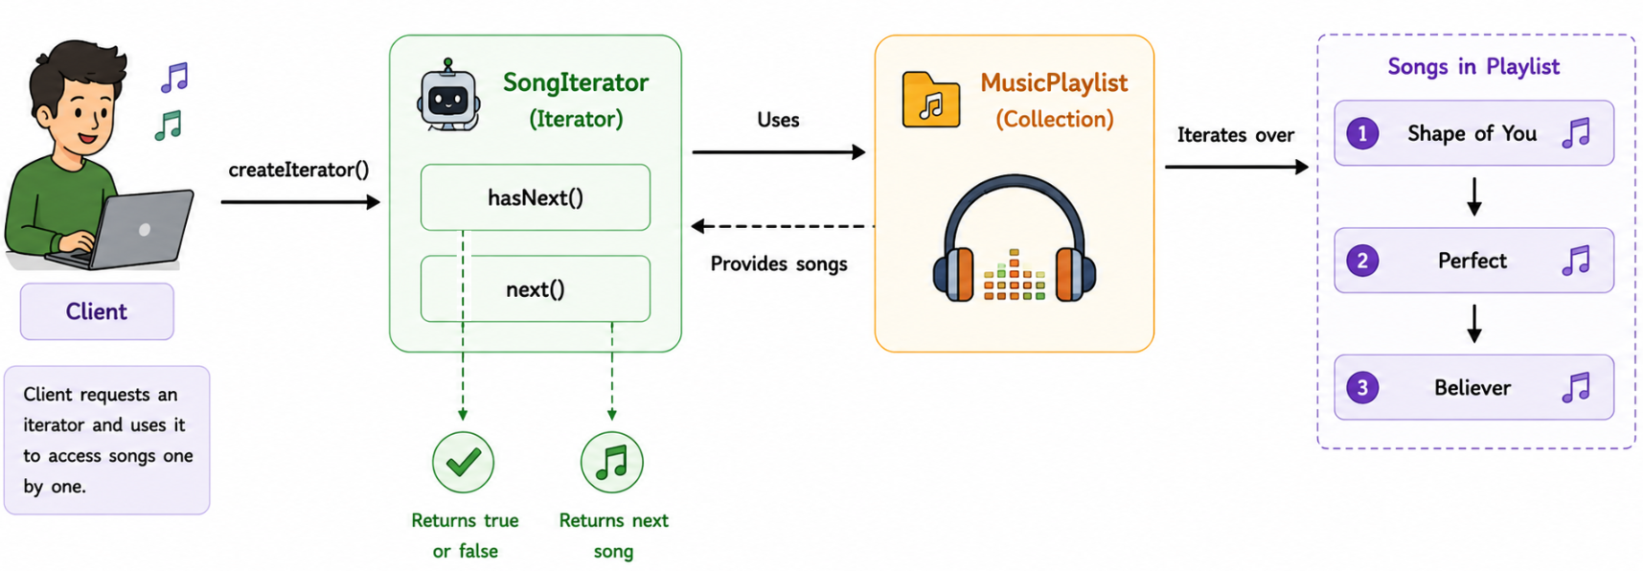
🔹 Implementation with Iterator Pattern

Step1: Iterator Interface

public interface Iterator {
boolean hasNext();
String next();
}

Step2: Aggregate Interface

public interface Playlist {
Iterator createIterator();
}

Step3: Concrete Collection
public class MusicPlaylist implements Playlist {
private String[] songs = {
"Shape of You",
"Perfect",
"Believer"
};
@Override
public Iterator createIterator() {
return new SongIterator(songs);
}
}

Step4: Concrete Iterator
public class SongIterator implements Iterator {
private String[] songs;
private int position = 0;
public SongIterator(String[] songs) {
this.songs = songs;
}
@Override
public boolean hasNext() {
return position < songs.length;
}
@Override
public String next() {
return songs[position++];
}
}

Step5: Client Code
public class IteratorPatternDemo {
public static void main(String[] args) {
Playlist playlist = new MusicPlaylist();
Iterator iterator = playlist.createIterator();
while(iterator.hasNext()) {
System.out.println(iterator.next()); //Shape of You, Perfect, Believer
}
}
}

🔹 Java Built in iterator:
List<String> names = Arrays.asList( "John", "Alice", "Bob" );
Iterator<String> iterator = names.iterator();
while(iterator.hasNext()) {
System.out.println(iterator.next());
}

- List -> Aggregate , Iterator -> Iterator
- ArrayList -> Concreate Aggregator , Java Iterator -> Concrete Iterator
🔹 Real-World Examples:
- Java Collections Framework – Iterator, ListIterator.
- Database ResultSet – Traverse records one row at a time.
- File Readers – Read lines sequentially.
- Browser History – Navigate through visited pages.
- Playlist Applications – Next/Previous songs.
- Library Management Systems – Traverse books.
- Tree Traversals – DFS, BFS iterators.
- Pagination Systems – Iterate through pages of data.

🔹 Adheres to SOLID Principles:
- Single Responsibility Principle (SRP): Collection stores data, iterator handles traversal.
- Open/Closed Principle (OCP): New iterator implementations can be added without modifying the collection.
- Dependency Inversion Principle (DIP): Client depends on the Iterator abstraction instead of concrete collections.

🔹 When to Use:
- You need to traverse a collection without exposing its internal structure.
- Multiple traversal strategies are required.
- Different collection implementations should provide a common traversal interface.
- Multiple clients need to iterate over the same collection independently.
- You want to decouple collection storage from traversal logic.

6. Mediator Pattern
The Mediator Pattern defines an object that encapsulates how a set of objects interact. Instead of objects communicating directly with each other, they communicate through a mediator, reducing dependencies between them.

Intent: To reduce direct coupling between multiple objects by introducing a mediator that coordinates their communication.

🔹 Key Points
Aspect | Detail
Problem Solved | Reduces tight coupling between multiple interacting objects
Type | Behavioural Pattern
Principle | Centralizes communication between objects
Flexibility | New colleagues can be added with minimal changes.
Coupling | Objects communicate through mediator instead of directly

🔹 Real-World Examples: Air Traffic Control (ATC)
Imagine multiple airplanes trying to communicate directly with each other.

❌Without Mediator Pattern (Direct Instantiation)
plane1.sendMessage(plane2);
plane1.sendMessage(plane3);
plane2.sendMessage(plane1);
plane3.sendMessage(plane2);
..............

- Every plane must know about every other airplane.
- Tight coupling among objects
- Difficult to add new participants.
- Communication logic is scattered.
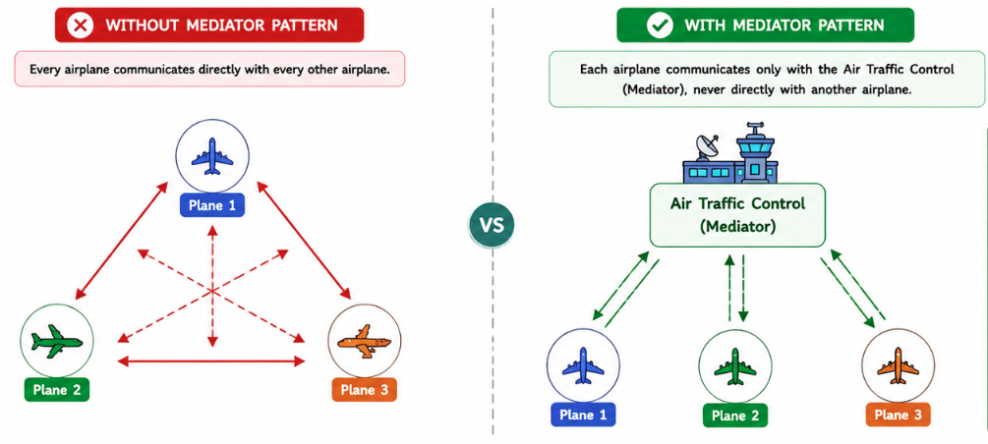
🔹 Implementation with Mediator Pattern

Each airplane communicates only with the Air Traffic Control, never directly with another airplane.

Step1: Mediator Interface

public interface ChatMediator {
void sendMessage(String message, User sender);
void addUser(User user);
}

Step2: Abstract Colleague
public abstract class User {
protected ChatMediator mediator;
protected String name;
public User(ChatMediator mediator, String name) {
this.mediator = mediator;
this.name = name;
}
public abstract void send(String message);
public abstract void receive(String message);
}

Step3: Concrete Mediator

import java.util.ArrayList;
import java.util.List;
public class ChatRoom implements ChatMediator {
private List<User> users = new ArrayList<>();
@Override
public void addUser(User user) {
users.add(user);
}
@Override
public void sendMessage(String message, User sender) {
for(User user : users) {
if(user != sender) {
user.receive(message);
}
}
}
}

Step4: Concrete Colleague
public class ChatUser extends User {
public ChatUser(ChatMediator mediator, String name) {
super(mediator, name);
}
@Override
public void send(String message) {
System.out.println(name + " sends: " + message);
mediator.sendMessage(message, this);
}
@Override
public void receive(String message) {
System.out.println(name + " received: " + message);
}
}
Step5: Client Code
public class MediatorPatternDemo {
public static void main(String[] args) {
ChatMediator mediator = new ChatRoom();
User john = new ChatUser(mediator, "John");
User alice = new ChatUser(mediator, "Alice");
User bob = new ChatUser(mediator, "Bob");
mediator.addUser(john);
mediator.addUser(alice);
mediator.addUser(bob);
john.send("Hello Everyone!");
}
}

#Output
John sends: Hello Everyone!
Alice received: Hello Everyone!
Bob received: Hello Everyone!

Communication Flow
John
│
│ send()
▼
Chat Room
│
├─────receive───► Alice
│
└──────receive──► Bob

🔹 Real-World Examples:
- Chat Applications – Chat room coordinates communication.
- Air Traffic Control Systems – Controls aircraft communication.
- Smart Home Hubs – Alexa, Google Home, SmartThings.
- GUI Frameworks – Dialog boxes coordinate multiple UI components.
- Flight Booking Systems – Coordinates airlines, payment, notifications.
- Online Auction Systems – Auctioneer mediates buyers and sellers.
- Stock Exchange – Exchange acts as mediator between buyers and sellers.
🔹 Adheres to SOLID Principles:
- Single Responsibility Principle (SRP): Colleagues focus on their own responsibilities, while the mediator manages communication.
- Open/Closed Principle (OCP): New colleague classes can be added without modifying existing colleagues.
- Dependency Inversion Principle (DIP): Colleagues depend on the ChatMediator abstraction instead of concrete colleagues.

🔹 When to Use:
Use the Mediator Pattern when:
- Many objects communicate with each other, creating complex dependencies.
- You want to reduce tight coupling between collaborating objects.
- Communication logic should be centralized in one place.
- Objects should not need to know about other concrete objects.
- You are building chat systems, GUI frameworks, workflow engines, or coordination services where multiple components interact frequently.

7. Memento Pattern
The Memento Pattern allows an object to save its internal state without exposing its implementation details, so that the object can be restored to that state later.

Intent: To capture and restore an object's state without violating encapsulation.

🔹 Key Points
Aspect | Detail
Problem Solved | Save and restore object’s previous state
Type | Behavioural Pattern
Principle | Preserves encapsulation while enabling undo/rollback
Participants | Originator, Memento, Caretaker
Common use cases | Undo/Redo, Checkpoints, save game.

🔹 Real-World Examples: Text Editor (Undo Feature)

❌Without Memento Pattern (Direct Instantiation)
document.setContent("Hello");
document.setContent("Hello World");
document.setContent("Hello World!!");
// User presses Undo
// Previous content is lost.

Once the content changes, there is no way to recover the previous version.
Problems
- No Undo functionality.
- Previous state is permanently lost.
- Backup logic becomes scattered.
- Encapsulation may be violated if state is exposed.

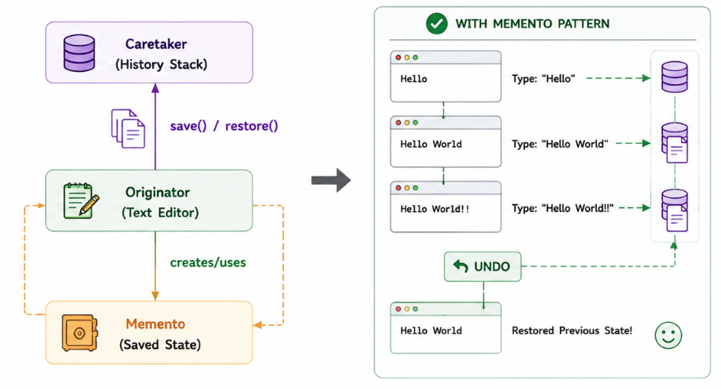
🔹 Implementation with Memento Pattern

Step1: Memento Class

// The Memento — an immutable snapshot of the Originator's internal state.
// It exposes no way to modify itself once created, only to read the saved value.
public class EditorMemento {
private final String content; // stores a frozen copy of the editor's content at save time
public EditorMemento(String content) {
this.content = content;
}
// Only the state is exposed for retrieval, no setters — keeps the snapshot immutable
public String getSavedContent() {
return content;
}
}

Step2: Originator Class
// The Originator — owns the actual state (content) and knows how to
// save/restore itself to/from a Memento. It's the only class that
// understands the internal structure of its own state.
public class TextEditor {
private String content; // the "live" current state of the editor
// Mutates current state
public void write(String content) {
this.content = content;
}
public void showContent() {
System.out.println(content);
}
// Creates a new Memento capturing the current content —
// this is how state gets "checkpointed" without exposing internals externally
public EditorMemento save() {
return new EditorMemento(content);
}
// Restores state from a given Memento — rolls the editor back to that snapshot
public void restore(EditorMemento memento) {
content = memento.getSavedContent();
}
}

Step3: Caretaker Class
mport java.util.Stack;
// The Caretaker — responsible for keeping track of Mementos over time
// (here, as an undo history), but never inspects or modifies their content.
// It just stores and hands them back — decoupled from the Originator's internals.
public class History {
private Stack<EditorMemento> history = new Stack<>(); // LIFO stack = undo history
// Push a new snapshot onto the history stack
public void save(EditorMemento memento) {
history.push(memento);
}
// Pop the most recent snapshot off the stack (used for undo)
public EditorMemento undo() {
return history.pop();
}
}

Step4: Client Code
public class MementoPatternDemo {
public static void main(String[] args) {
TextEditor editor = new TextEditor(); // Originator
History history = new History(); // Caretaker
// Write "Hello", then checkpoint this state into history
editor.write("Hello");
history.save(editor.save());
// Write "Hello World", then checkpoint this state too
editor.write("Hello World");
history.save(editor.save());
// Write again but do NOT save a checkpoint for this one —
// so this state is only recoverable by manually re-writing it, not via undo
editor.write("Hello World!!");
System.out.println("Current:");
editor.showContent(); // prints: Hello World!!
// Undo: pop the last saved memento ("Hello World") and restore editor to it
editor.restore(history.undo());
System.out.println("After Undo:");
editor.showContent(); // prints: Hello World
// Undo again: pop the earlier saved memento ("Hello") and restore to it
editor.restore(history.undo());
System.out.println("Second Undo:");
editor.showContent(); // prints: Hello
}
}

🔹 Real-World Examples:
- Text Editors – Undo/Redo (MS Word, VS Code, IntelliJ).
- Games – Save points and checkpoints.
- Database Systems – Transaction rollback.
- Photo Editors – Undo editing operations.
- Version Control Systems – Restore previous versions.
- Workflow Engines – Rollback failed processes.
- Financial Applications – Restore transaction state after failures.
🔹 Adheres to SOLID Principles:
- Single Responsibility Principle (SRP):
  - Originator manages its own state.
  - Memento stores the snapshot.
  - Caretaker manages history.
- Open/Closed Principle (OCP): New types of mementos can be introduced without changing existing code.
- Dependency Inversion Principle (DIP): Client interacts with abstractions rather than manipulating internal object state directly.

🔹 When to Use:
Use the Memento Pattern when:
- You need Undo/Redo functionality.
- An object's previous state must be restored later.
- You want to preserve encapsulation while saving object state.
- You are implementing checkpoints, rollback mechanisms, or version history.
- State restoration should be independent of the object's business logic.

8. Observer Pattern
The Observer Pattern defines a one-to-many dependency between objects so that when one object (Subject) changes its state, all its dependent objects (Observers) are automatically notified and updated.

Intent: To establish publish - subscribe mechanism where multiple objects can react automatically to changes in another object.

🔹 Key Points
Aspect | Detail
Problem Solved | Automatically notifies multiple objects when state changes
Type | Behavioural Pattern
Principle | Implements one-to-many dependency between objects
Communication | Subject pushed notifications to all registered observers
Best Used | Event handling, Notifications, Real-time updates

🔹 Real-World Examples: YouTube Channel Notifications

❌Without Observer Pattern (Direct Instantiation)
user1.notify();
user2.notify();
user3.notify();
user4.notify();
user5.notify();
...

- Whenever video is uploaded, the channel must manually notify every subscriber.
- Tight coupling between channel and subscribers.
- Difficult to add/remove subscribers
- Notification logic is scattered.
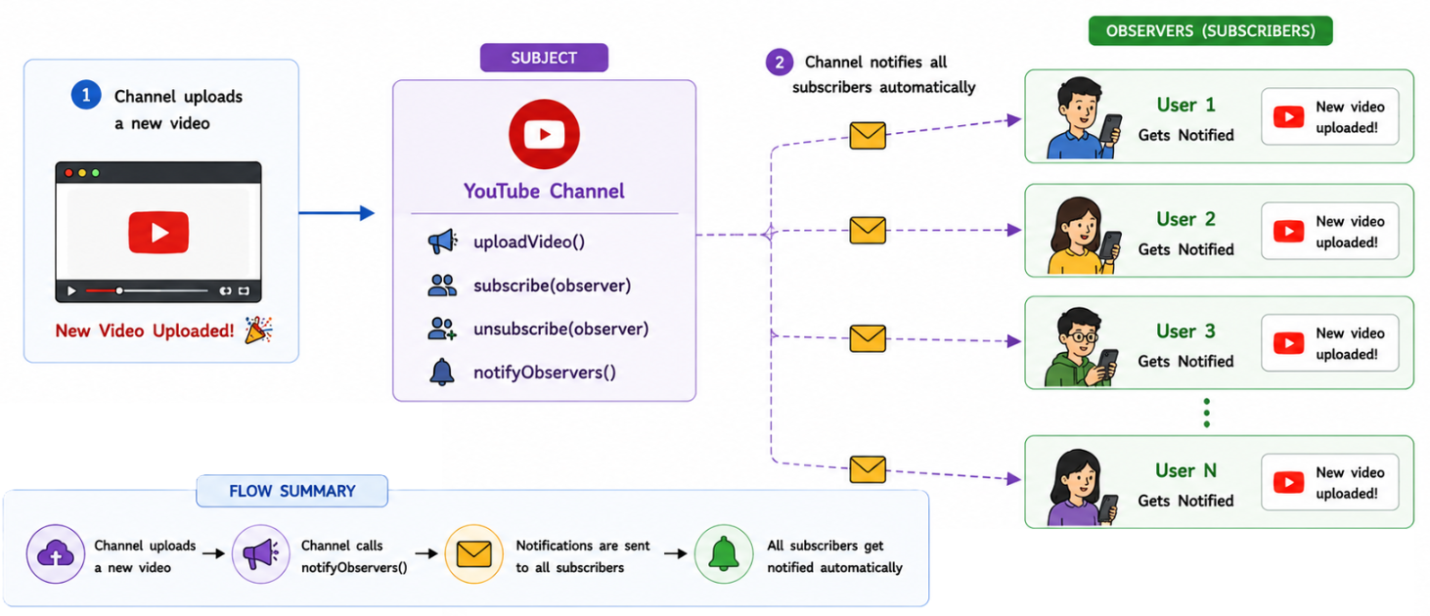
🔹 Implementation with Observer Pattern

Whenever the channel uploads a video, every subscribed user automatically gets notified.

Step1: Observer Interface

public interface Subscriber {
// Called whenever the channel uploads a new video
void update(String videoTitle);
}

Step2: Subject Interface

public interface YouTubeChannel {
void subscribe(Subscriber subscriber);
void unsubscribe(Subscriber subscriber);
void notifySubscribers();
}

Step3: Concrete Subject
public class TechChannel implements YouTubeChannel {
private List<Subscriber> subscribers = new ArrayList<>(); // List of all subscribers
private String latestVideo; // Latest uploaded video
@Override
public void subscribe(Subscriber subscriber) {
subscribers.add(subscriber);
}
@Override
public void unsubscribe(Subscriber subscriber) {
subscribers.remove(subscriber);
}
@Override
public void notifySubscribers() {
// Notify every subscriber
for (Subscriber subscriber : subscribers) {
subscriber.update(latestVideo);
}
}
// Upload a new video
public void uploadVideo(String title) {
System.out.println("\nNew Video Uploaded : " + title);
latestVideo = title;
notifySubscribers(); // Notify all subscribers automatically
}
}

Step4: Concrete Observer
public class User implements Subscriber {
private String name;
public User(String name) {
this.name = name;
}
@Override
public void update(String videoTitle) {
// Called by the subject whenever a new video is uploaded
System.out.println(name + " received notification: " + videoTitle);
}
}
Step5: Client Code

public class ObserverPatternDemo {
public static void main(String[] args) {
// Create the YouTube channel
TechChannel channel = new TechChannel();
// Create subscribers
Subscriber john = new User("John");
Subscriber alice = new User("Alice");
Subscriber bob = new User("Bob");
// Subscribe users
channel.subscribe(john);
channel.subscribe(alice);
channel.subscribe(bob);
// Upload first video
channel.uploadVideo("Spring Boot Tutorial");
// Alice unsubscribes
channel.unsubscribe(alice);
// Upload second video
channel.uploadVideo("Observer Design Pattern");
}
}

🔹 Real-World Examples:
- YouTube Notifications
- Instagram Followers: Notification on posts added
- Weather Monitoring Systems: Alerts related to weather
- Stock Market Applications: alerts about important news
- News Subscription Apps
- Spring Event Publishing: Pub sub model
- Java Swing Event Listeners
- E-Commerce "Notify Me" Feature: Notifies on updates of product in user’s cart
- Kafka Consumers: Pub-sub model
- RabbitMQ Subscribers

🔹 Adheres to SOLID Principles:
- Single Responsibility Principle (SRP):
Subject manages observers.
Observer handles update logic.
- Open/Closed Principle (OCP):
New observers can be added without modifying the subject.
- Dependency Inversion Principle (DIP):
Subject depends on the Subscriber abstraction, not concrete observer classes.

🔹 When to Use:
Use the Observer Pattern when:
- Multiple objects need to react automatically to changes in another object.
- You need an event-driven architecture.
- You want to implement publish-subscribe behaviour.
- Objects should remain loosely coupled.
- You are building notification systems, event listeners, messaging systems, stock market apps, weather monitoring systems, or real-time dashboards.

9. State Pattern
The State Pattern allows an object to alter its behaviour when it’s internal state changes. The object appears to change its class by delegating behaviour to different state objects.

Intent: To allow an object to change its behaviour dynamically based on its current state without using large conditional statements.

🔹 Key Points
Aspect | Detail
Problem Solved | Eliminates large if-else or switch statements on object state
Type | Behavioural Pattern
Principle | Encapsulates state-specific behaviour into separate class
Flexibility | New states can be added without modifying existing code
Best Used | State Machines, Workflow Systems, Order Processing

🔹 Real-World Examples: Vending Machine
Suppose Vending Machine has 3 states: No Coin, Has Coin, Dispensing items
❌Without State Pattern (Direct Instantiation)

if(state.equals("NO_COIN")){
// Insert coin
}
else if(state.equals("HAS_COIN")){
// Dispense item}
}
else if(state.equals("DISPENSING")){
// Finish transaction
}

- Large if-else chains.
- Difficult to add new states.
- State transition logic is scattered.
- Violates Open/Closed Principle.
- Hard to maintain.
🔹 Implementation with State Pattern
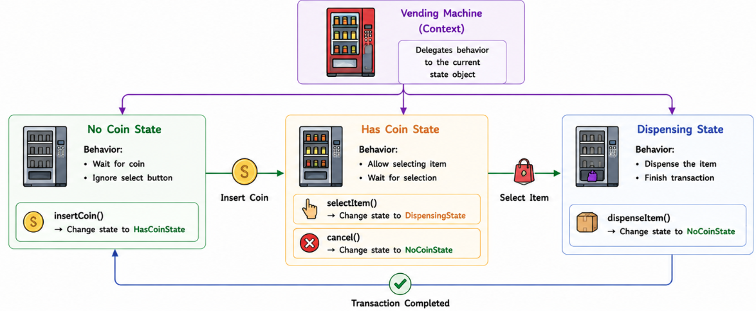

Step1: State Interface
public interface State {
void insertCoin(VendingMachine machine); // Action performed when a coin is inserted
void dispense(VendingMachine machine); // Action performed when the item is dispensed
}

Step2: Subject Interface
public class VendingMachine {
private State state; // Current state of the machine
public VendingMachine() {
state = new NoCoinState();
}
public void setState(State state) {
this.state = state;
}
public void insertCoin() {
state.insertCoin(this);
}
public void dispense() {
state.dispense(this);
}
}
Step3: Concrete States
public class NoCoinState implements State {
@Override
public void insertCoin(VendingMachine machine) {
System.out.println("Coin Inserted.");
machine.setState(new HasCoinState()); // Change state after coin insertion
}
@Override
public void dispense(VendingMachine machine) {
System.out.println("Insert coin first.");
}
}

public class HasCoinState implements State {
@Override
public void insertCoin(VendingMachine machine) {
System.out.println("Coin already inserted.");
}
@Override
public void dispense(VendingMachine machine) {
System.out.println("Dispensing Item...");
machine.setState(new DispensingState()); // Move to dispensing state
}
}

public class DispensingState implements State {
@Override
public void insertCoin(VendingMachine machine) {
System.out.println("Please wait...");
}
@Override
public void dispense(VendingMachine machine) {
System.out.println("Item Dispensed.");
// Return to initial state
machine.setState(new NoCoinState());
}
}

Step4: Client Code
public class StatePatternDemo {
public static void main(String[] args) {
VendingMachine machine = new VendingMachine();
machine.dispense();
machine.insertCoin();
machine.dispense();
machine.dispense();
}
}
//Output
//Insert coin first.
//Coin Inserted.
//Dispensing Item...
//Item Dispensed.

- This chained the states:
No Coin ----> Has Coin ----> Dispensing ----> (back to No Coin)
- Another real world example: Order Processing:
Placed ----> Confirmed ----> Shipped ----> Delivered
- Same with Traffic Signal:
Red ----> Green ----> Yellow ----> Red ---->….

🔹 Real-World Examples:
- Vending Machines
- ATM Machines
- Order Management Systems
- Workflow Engines
- Traffic Signal Controllers
- Media Players
- Game Character States (Running, Jumping, Attacking)
- Document Lifecycle (Draft → Review → Published)
- Elevator Control Systems

🔹 Adheres to SOLID Principles:
- Single Responsibility Principle (SRP): Each state class handles behaviour for one specific state.
- Open/Closed Principle (OCP): New states can be added without modifying existing state classes.
- Dependency Inversion Principle (DIP): The context depends on the State abstraction rather than concrete state implementations.

🔹 Advantages:
- Eliminates complex if-else or switch statements.
- State-specific logic is isolated.
- Easy to introduce new states.
- Improves readability and maintainability.
- Supports dynamic behaviour changes.

🔹 When to Use:
Use the State Pattern when:
- An object's behaviour depends on its current state.
- You have many conditional statements based on state.
- State transitions should be cleanly encapsulated.
- You are implementing state machines or workflows.
- You are building systems like vending machines, order processing, media players, traffic lights, or document lifecycle management where behaviour changes as the object's state changes.

10. Template Method Pattern
The Template Method Pattern defines the skeleton of an algorithm in a superclass while allowing subclasses to override specific steps without changing the overall algorithm structure.
Intent: To define the overall workflow of an algorithm in a base class while letting subclasses customize certain steps.

🔹 Key Points
Aspect | Detail
Problem Solved | Prevents duplication of common algorithm structure
Type | Behavioural Pattern
Principle | Defines algorithm skeleton in base class and delegates specific steps to subclass
Reusability | Common logic is reused across multiple implementations
Best Used | Workflows where most steps are common but few differ

🔹 Real-World Examples: Online Order Processing
Suppose an e-commerce application processes different types of orders
❌Without Template Method Pattern (Direct Instantiation)
if(orderType.equals("ONLINE")){
validateOrder();
calculatePrice();
processOnlinePayment();
shipOrder();
}
else if(orderType.equals("COD")){
validateOrder();
calculatePrice();
markCashOnDelivery();
shipOrder();
}

- Duplicate code.
- Difficult to maintain.
- Violates DRY principle.
- Hard to introduce new order types.
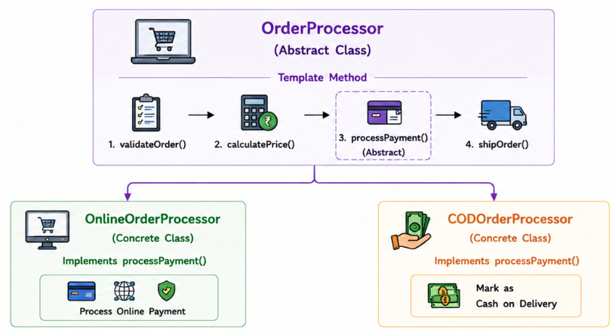
🔹 Implementation with Template Method Pattern

Step1: Abstract Class (Template)
public abstract class OrderProcessor {
// Template Method
public final void processOrder() {
validateOrder();
calculatePrice();
makePayment();
shipOrder();
}
private void validateOrder() {
System.out.println("Validating Order...");
}
private void calculatePrice() {
System.out.println("Calculating Total Price...");
}
// Step to be implemented by subclasses
protected abstract void makePayment();
private void shipOrder() {
System.out.println("Shipping Order...");
}
}

Step2: Concrete Classes
//Online Order
public class OnlineOrderProcessor extends OrderProcessor {
@Override
protected void makePayment() {
// Online payment implementation
System.out.println("Processing Online Payment...");
}
}

//Cash on delivery
public class CODOrderProcessor extends OrderProcessor {
@Override
protected void makePayment() {
// Cash on delivery implementation
System.out.println("Payment will be collected on Delivery.");
}
}

Step3: Client Code
public class TemplateMethodDemo {
public static void main(String[] args) {
OrderProcessor online = new OnlineOrderProcessor();
online.processOrder();
System.out.println();
OrderProcessor cod = new CODOrderProcessor();
cod.processOrder();
}
}
//Validating Order...
//Calculating Total Price...
//Processing Online Payment...
//Shipping Order...
//
//Validating Order...
//Calculating Total Price...
//Payment will be collected on Delivery.
//Shipping Order...

🔹 Real-World Examples:
- Spring Framework (JdbcTemplate) – Defines the database access workflow while allowing developers to provide only SQL and row-mapping logic.
- Java HttpServlet – The servlet container calls service(), which internally delegates to doGet(), doPost(), etc.
- JUnit Test Framework – Executes a fixed test lifecycle (@BeforeEach → Test → @AfterEach) while allowing custom test implementations.
- Data Processing Pipelines – Common validation and processing steps remain the same, while business-specific processing varies.
- Report Generation Systems – The report generation flow is fixed, but PDF, Excel, or HTML formatting differs.
- Online Order Processing – Validation and shipping remain the same, while payment methods differ.
- Employee On boarding – Standard on boarding steps remain the same while department-specific training changes.

🔹 Adheres to SOLID Principles:
- Single Responsibility Principle (SRP): The superclass manages the workflow, while subclasses implement only varying behaviour.
- Open/Closed Principle (OCP): New implementations can be added by creating new subclasses without modifying existing code.
- Liskov Substitution Principle (LSP): Any subclass can replace the base class without affecting the algorithm.
- Dependency Inversion Principle (DIP): High-level workflow depends on abstract operations implemented by subclasses.

🔹 When to Use:
Use the Template Method Pattern when:
- Multiple classes follow the same overall workflow but differ in a few steps.
- You want to eliminate duplicate algorithm code.
- The algorithm structure should remain fixed while allowing customization.
- You are implementing frameworks, processing pipelines, report generators, or lifecycle-based operations.
- You want to enforce a standard sequence of operations while allowing subclasses to customize specific behaviour.

11. Visitor Pattern
The Visitor Pattern lets you add new operations to a group of existing objects without modifying their classes. It separates the algorithm (operation) from the objects on which it operates.

Intent: To define new operations on a set of objects without changing their structure.

🔹 Key Points
Aspect | Detail
Problem Solved | Adds new operations to existing object structure without modifying them
Type | Behavioural Pattern
Principle | Separates operations from object structure
Flexibility | New operations can be added by creating new visitors
Best Used | Object structures that rarely change but require new operations frequently.

🔹 Real-World Examples: Shopping Cart Checkout
Suppose e-commerce application has different item types
❌Without Visitor Pattern (Direct Instantiation)
if(item instanceof Book){
// Calculate book discount
}
else if(item instanceof Electronics){
// Calculate electronics discount
}
else if(item instanceof Grocery){
// Calculate grocery discount
}

- Suppose we need separate logics for tax calculation, shipping cost, loyalty points etc. We will end up writing multiple of-else blocks
- Every new operation requires modifying existing classes
- Business logic gets scattered.
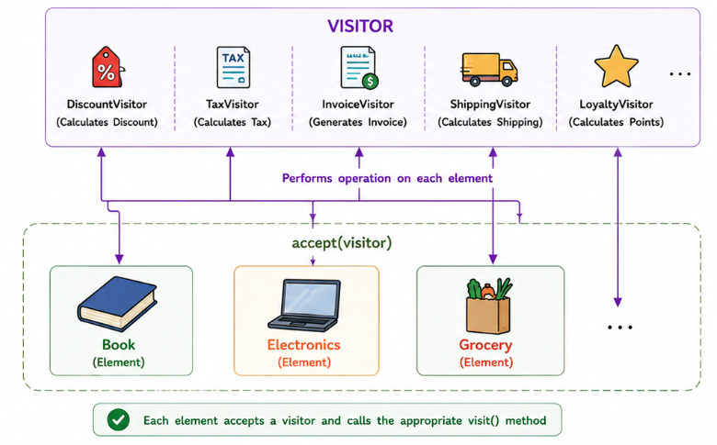
🔹 Implementation with Visitor Pattern

Step1: Visitor Interface
//implemented by operation classes:
//DiscountVisitor, TaxVisitor, InvoiceVisitor....
public interface ShoppingCartVisitor {
void visit(Book book);
void visit(Electronics electronics);
}

Step2: Element Interface
//Implemented by objects like book, electronic etc....
public interface Item {
// Accept any visitor
void accept(ShoppingCartVisitor visitor);
}

Step3: Concrete Elements

public class Book implements Item {
private int price;
public Book(int price) {
this.price = price;
}
public int getPrice() {
return price;
}
// Using this method, client code will add visitors to the items
@Override
public void accept(ShoppingCartVisitor visitor) {
// Pass current object to visitor
visitor.visit(this);
}
}

public class Electronics implements Item {
private int price;
public Electronics(int price) {
this.price = price;
}
public int getPrice() {
return price;
}
// Using this method, client code will add visitors to the items
@Override
public void accept(ShoppingCartVisitor visitor) {
// Pass current object to visitor
visitor.visit(this);
}
}

Step4: Concrete Visitors

public class DiscountVisitor implements ShoppingCartVisitor {
@Override
public void visit(Book book) {
// Apply 10% discount
int discountedPrice = (int)(book.getPrice() * 0.9);
System.out.println("Book Price after Discount : ₹" + discountedPrice);
}
@Override
public void visit(Electronics electronics) {
// Apply 20% discount
int discountedPrice =(int)(electronics.getPrice() * 0.8);
System.out.println("Electronics Price after Discount : ₹" + discountedPrice);
}
}

Step5: Client Code

public class VisitorPatternDemo {
public static void main(String[] args) {
Item[] items = {
new Book(500),
new Electronics(20000)
};
ShoppingCartVisitor visitor = new DiscountVisitor();
// Apply visitor to every item
//Any visitor(operation) can be applied to any Item at runtime
for(Item item : items) {
item.accept(visitor);
}
}
}

Discount Visitor
↓
Book.accept(visitor)
↓
visitor.visit(Book)

🔹 Real-World Examples:
- Compiler Abstract Syntax Trees (ASTs) – Different visitors perform type checking, optimization, and code generation on the same syntax tree.
- Shopping Cart Systems – Discount calculation, tax calculation, invoice generation, and shipping cost calculation are implemented as different visitors.
- File Systems – Calculate folder size, compress files, perform backups, or scan for viruses without modifying file classes.
- Hospital Management Systems – Generate salary, attendance, and performance reports for employees.
- Document Processing – Export documents to PDF, HTML, Word, or Markdown using different visitors.
- CAD Software – Perform rendering, measurement, and validation on design elements.
- Game Engines – Collision detection, rendering, and AI processing on game objects.

🔹 Adheres to SOLID Principles:
- Single Responsibility Principle (SRP): Element classes manage data, while visitors implement operations.
- Open/Closed Principle (OCP): New operations can be added by creating new visitors without modifying element classes.
- Dependency Inversion Principle (DIP): Client depends on the Visitor and Item abstractions rather than concrete implementations.

🔹 When to Use:
Use the Visitor Pattern when:
- You need to perform many different operations on the same object structure.
- The object hierarchy is stable and rarely changes.
- You want to add new functionality without modifying existing classes.
- You want to avoid large instanceof or type-checking logic.
- You are building compilers, reporting systems, shopping carts, file systems, document processors, or game engines where the data structure remains stable but new operations are added frequently.

